n

Group

01

|  |  |
| --- | --- |
| Name | ID |
| ONIK, MD. SABBIR HOSSAIN | 22-46712-1 |
| ISLAM, RAIHANUL | 22-46680-1 |
| NINE, MALEK AL JULKAR | 22-46702-1 |
| NURSHED, NUR-E HABIB | 22-46702-1 |

“*Rent Management System*”



AMERICAN INTERNATIONAL UNIVERSITY–BANGLADESH

(AIUB)

Introduction to Database

  Semester: Fall 2022-23

**Scenario:**

In a House Rent Management System Customer will choice their suitable houses that House Owners put in the management system.

In House Rent Management System, a company will be identified by EIIN Number. House Rent Management System Manage Many Employees. Employees can be identified by Eid Number. Employees have Department, Salary, Name. Employee Maintain Rental Items. Rental Item has Unique RI_id. Customer has CU_id, Firstname, Lastname, Email, Address. Customer choice Rental Item as they Want. Whatever Rental Item Customer Chose it will deliverd from House Rent Management System. Customer pay Payment. To identify payment individually Payment has Payment_id. This Payment goes to house Rent Management System. House Owners Contact House Rent Management System to put up their house for rent. House Owner has uniquely identified HO_id. It also has Address, FirstName, LastName, Email. House Owner has 3 type of houses Family House, Office Space, Bachelor Mech. Each Rental Item has Unique FO_id, OS_id, BM_id. Bachelor Mech has many Sublets. Sublet has S_id to uniquely identify it.

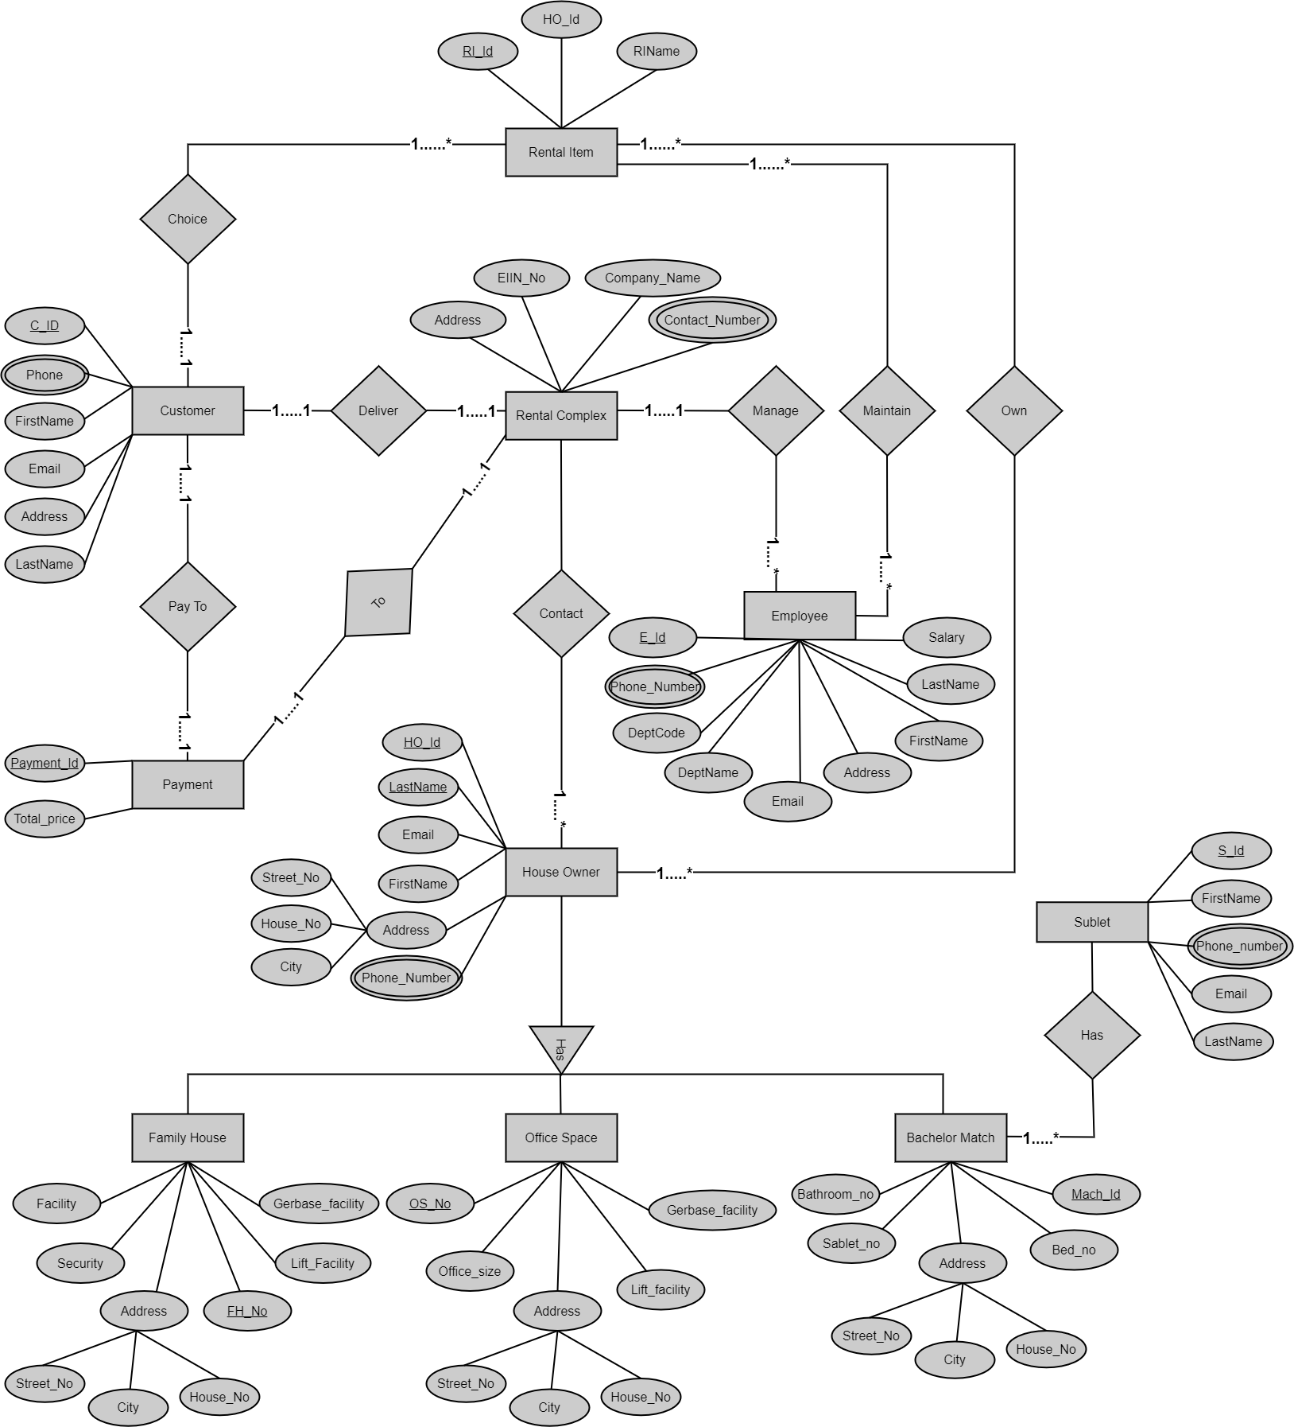**ER-Diagram:**

**Normalization:**

***UNF:*** RENTAL COMPLEX MANAGE EMPLOYEE

MANAGE (EIIN_NO, AUTHORITY, PHONE_NO, Address, E_ID, City, Email, FIRST_name, LAST_NAME, DEPT_name, Dept_code, salary)

***1NF:***

* Phone_NO is a multivalued Attribute.

MANAGE (EIIN_NO, Authority, Address, E_ID, City, Email, FIRST_name, LAST_NAME, DEPT_name, Dept_code, salary)

***2NF:***

1. Phone_id, Phone_NO.
2. EIIN_NO, Authority, Address, Email, Phone_id.
3. E_id, Phone_id, city, Email, FIRST_name, LAST_NAME, Dept_code, Dept_name, salary.

***3NF:***

1. Phone _ id, Phone,
2. EIIN _ NO, Phone id, Authority, ADDRESS, EMAIL.
3. NID, FIRST_name, LAST_NAME.
4. E_id, Dept_code, Dept_name.
5. E_id, Phone _ id, city, EMAIL, NID, salary.

***UNF:*** RENTAL COMPLEX CONTACTED BY HOUSE OWNER

CONTACT (EIIN_NO, Authority_NAME, FIRST_NAME, LAST_NAME, City, House_No, Street_No, Post_NO, EMAIL)

***1NF:***

* Phone is a multi valued Attribute.

CONTACT (EIIN_NO, Authority, FIRST_NAME, LAST_NAME, City, House_No, Street_No, Post_NO, EMAIL Address_ID, Ho-id)

***2NF:***

1. Phone _id, Phone_NO
2. EIIN _ NO, Authority_NAME, Address_ID.
3. HoUSE_id, O_FNAME, O_Lname, House –_No, Street-No, Post-No,

***3NF:***

1. Phone _ id, Phone_NO.
2. EIIN _ NO, Phone_id, Authority_NAME, Address_ID.
3. NID, FIRST_Name, LAST_name.
4. O_ID, CITY, House_No, Street_No, Post_No, Email.
5. HO_ID, NID, PHONE_NO, Email.

***UNF:*** RENTAL COMPLEX DELIVER TO CUSTOMER

DELIVER(C0_id, phone, c_name_email, address, eiin_no, authority_name, phone_no, address)

***1NF:***

* Phone_NO is a multivalued Attribute.

DELIVER(C0_id, c_name_email, address, eiin_no, authority_name, address)

***2NF:***

1. Phone _id, Phone
2. EIIN _ no, Authority, Address, Phone id .
3. C_id,Email, City, CFrone,CFname,CLname, Phone id .

***3NF:***

1. Phone _ id, Phone,
2. EIIN _ No, Authority, Address, Phone id .
3. N_ID,C Fmame, C Lname.
4. co_id, Nid, CITY, Phone_id

***UNF:*** customer pays payment

pay(C0_id, phone, c_name_email, address,payment_id, price)

***1nf:***

* Phone_NO is a multivalued Attribute.

pay(C0_id, c_name_email, address,payment_id, price)

***2nf:***

1. Phone _id, Phone.
2. Payment_id, Price, Payment methed.
3. C_id,Email, City, CFrone, CFname, CLname, Phone id.

***3NF:***

1. PHONE _id, Phone.
2. Payment_id, Price, Payment methed.
3. NID, C Fmame, C Lname.
4. Co_id, N_ID, Phone _ID, EMAIL,City.

***UNF:*** payment pay to rental complex

PAY (payment_id, price, eiin_no, authority_name, phone_no, address)

***1NF:***

* Phone_NO is a multivalued Attribute.

pay(payment_id, price, eiin_no, authority_name, address)

***2NF:***

1. Phone _id, Phone.
2. EIIN _ NUM, Authority, Address, Email .
3. Payment_id, Price, Payment_methed.

***3NF:***

* No need for 3NF

***UNF:*** bachelor mech has sublet

has (bathroom_no, sublet_no_bed_no_mech_id,s_id, name, phone_no, email)

***1NF:***

* Phone_NO is a multivalued Attribute.

has (bathroom_no, sublet_no_bed_no_mech_id,s_id, name, email)

***2NF:***

1. Phone _id, Phone.
2. Mech_id, Bachelor_No, Bad_No, Sublet_Num, Street_NO, HOUSE_No,Rent.
3. Sublet_ID, first_NAME, LAST_name, City,Email.

***3NF:***

1. Phone _id, Phone.
2. Mech_id, Bachelor_No, Bad_No, Sublet_Num.
3. Mech_ID, CITY, Street,House_No.
4. N_ID, S Fmame, S Lname.
5. Sublet_ID, NID , City, Email, Phone _id .

***UNF:*** customer choice rental item

CHOICE (C0_id, phone, c_name_email, address,ri_id, ho_name, ri_name)

***1NF:***

* Phone_NO is a multivalued Attribute.

CHOICE (C0_id c_name_email, address,ri_id, ho_name, ri_name)

***2NF:***

1. Phone _id, Phone.
2. cu_ID, EmaiL,Addreass,Cus_Name.
3. RI_ID, HO_id,RI name.

***3NF:***

1. Phone _id, Phone.
2. N_ID, first_NAME, last_name.
3. C_id, N_ID, EMAIL, ADDRESS.
4. RI_ID, HO_ID, RI_Name.

***UNF:*** employee manage rental item

MANAGE(e_id,phone,dept_code_dept_name_email_address_salary,ri_id, ho_name, ri_name)

***1NF:***

* Phone_NO is a multivalued Attribute.

manage(e_id,dept_code_dept_name_email_address_salary,ri_id, ho_name, ri_name)

***2NF:***

1. Phone _id, Phone.
2. RI_ID, HO_ID, RI Name.
3. E_ID, PHONE_ID, NID, CITY, EMAIL, Dept_code.
4. Dept_CODE, DEPT_NAME, SALARY.
5. N_ID, E First_name, last_name.

***3NF:***

* No need for 3NF

***UNF:*** house owner own rental item

own(ho_id, email, phone, address, owner_name, ri_id, ho_name, ri_name)

***1NF:***

* Phone_NO is a multivalued Attribute.

own(ho_id, email, address, owner_name, ri_id, ho_name, ri_name)

***2NF:***

1. Phone _id, Phone
2. RI_ID, Ho_id , RI Name.
3. Ho_id, First_name, Last_name, City, House_NO, EMAIL.

***3nf:***

1. Phone _id, Phone.
2. RI_ID, HO_ID, RI Name.
3. Ho_ID, EMAIL, N_ID, Phone_id.
4. First_name, last_NAME, NID.
5. CITY, HOUSE_No, Street_no, Ho_id.

***table selection:***

1. Phone _ id, Phone,
2. EIIN _ NO, Phone id, Authority, ADDRESS, EMAIL.
3. NID, FIRST_name, LAST_NAME.
4. E_id, Dept_code, Dept_name.
5. E_id, Phone _ id, city, EMAIL, NID, salary.
6. Phone _ id, Phone_NO.
7. EIIN _ NO, Phone_id, Authority_NAME, Address_ID.
8. NID, FIRST_Name, LAST_name.
9. O_ID, CITY, House_No, Street_No, Post_No, Email.
10. HO_ID, NID, PHONE_NO, Email.
11. Phone _ id, Phone,
12. EIIN _ No, Authority, Address, Phone id .
13. N_ID,C Fmame, C Lname.
14. co_id, Nid, CITY, Phone_id
15. PHONE _id, Phone.
16. Payment_id, Price, Payment methed.
17. NID, C Fmame, C Lname.
18. Co_id, N_ID, Phone _ID, EMAIL,City.
19. Phone _id, Phone.
20. EIIN _ NUM, Authority, Address, Email .
21. Payment_id, Price, Payment_methed.
22. Phone _id, Phone.
23. Mech_id, Bachelor_No, Bad_No, Sublet_Num.
24. Mech_ID, CITY, Street,House_No.
25. N_ID, S Fmame, S Lname.
26. Sublet_ID, NID , City, Email, Phone _id .
27. Phone _id, Phone.
28. N_ID, first_NAME, last_name.
29. C_id, N_ID, EMAIL, ADDRESS.
30. RI_ID, HO_ID, RI_Name.
31. Phone _id, Phone.
32. RI_ID, HO_ID, RI Name.
33. E_ID, PHONE_ID, NID, CITY, EMAIL, Dept_code.
34. Dept_CODE, DEPT_NAME, SALARY.
35. N_ID, E First_name, last_name.
36. Phone _id, Phone.
37. RI_ID, HO_ID, RI Name.
38. Ho_ID, EMAIL, N_ID, Phone_id.
39. First_name, last_NAME, NID.
40. CITY, HOUSE_No, Street_no, Ho_id.

***final table:***

1. Phone_id, phone.
2. EIIN _ No, Authority_name, Phone_id.
3. NID, first_name, last_name.
4. Dept_code, Dept_Name, Salary.
5. e_id, City, Email, Nid, Salary, Dept_Code, Phone_id.
6. Address_id, House_No, Street_No, City.
7. Ho_id, city, Email, Address_ID, NID, phone_ID.
8. Cu_id, EMAIL, City, N_id, PHONE_id.
9. Payment_id, Price, Payment_methed.
10. Mech_id, Bathroom_No, Bed_No, Sublet_No.
11. Sublet_id, city, Email, NID, Mech_id, Phone_id.
12. RI_ID, RI Name, Ho_id.
13. fh_id, secuirity, bed_no, lift_facility, address_id.
14. os_id, office_size, secuirity, lift_facility, garage_facility, address_id.

**Table Creation:**

**PHONE TABLE:**

CREATE TABLE PHONE(

PHONE_ID NUMBER(10) PRIMARY KEY,

PHONE_NO VARCHAR2(20) );

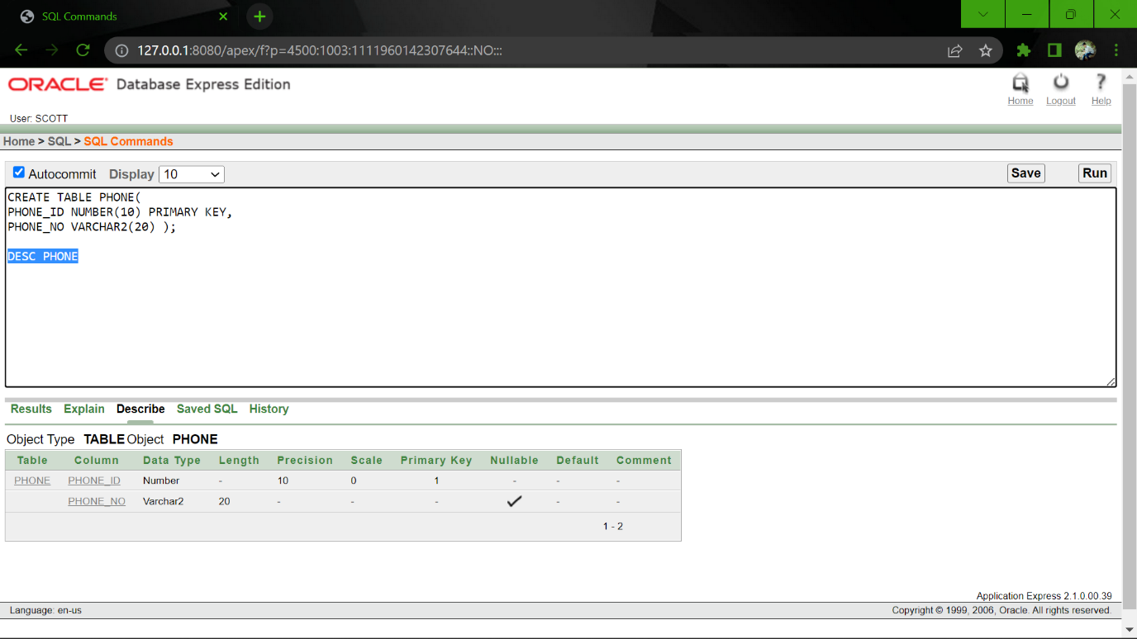DESC PHONE

**AUTHORITY TABLE:**

CREATE TABLE AUTHORITY(

EIIN_NO NUMBER(10) PRIMARY KEY,

AUTHORITY_NAME VARCHAR2(20),

PHONE_ID REFERENCES PHONE );

DESC AUTHORITY

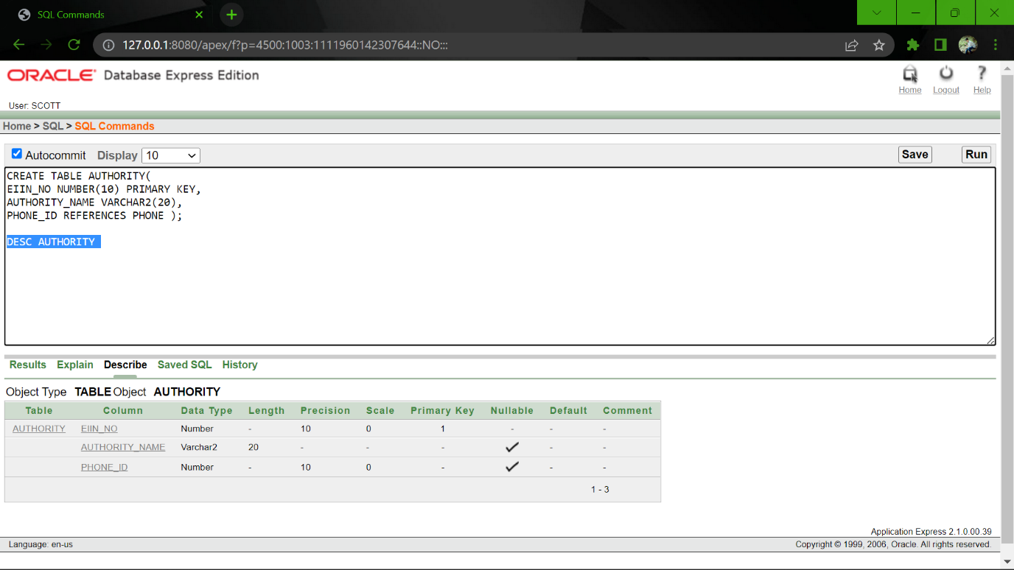

**NAME TABLE:**

CREATE TABLE NAME(

NID VARCHAR2(20) PRIMARY KEY,

FIRST_NAME VARCHAR2(20),

LAST_NAME VARCHAR2(20) );

DESC NAME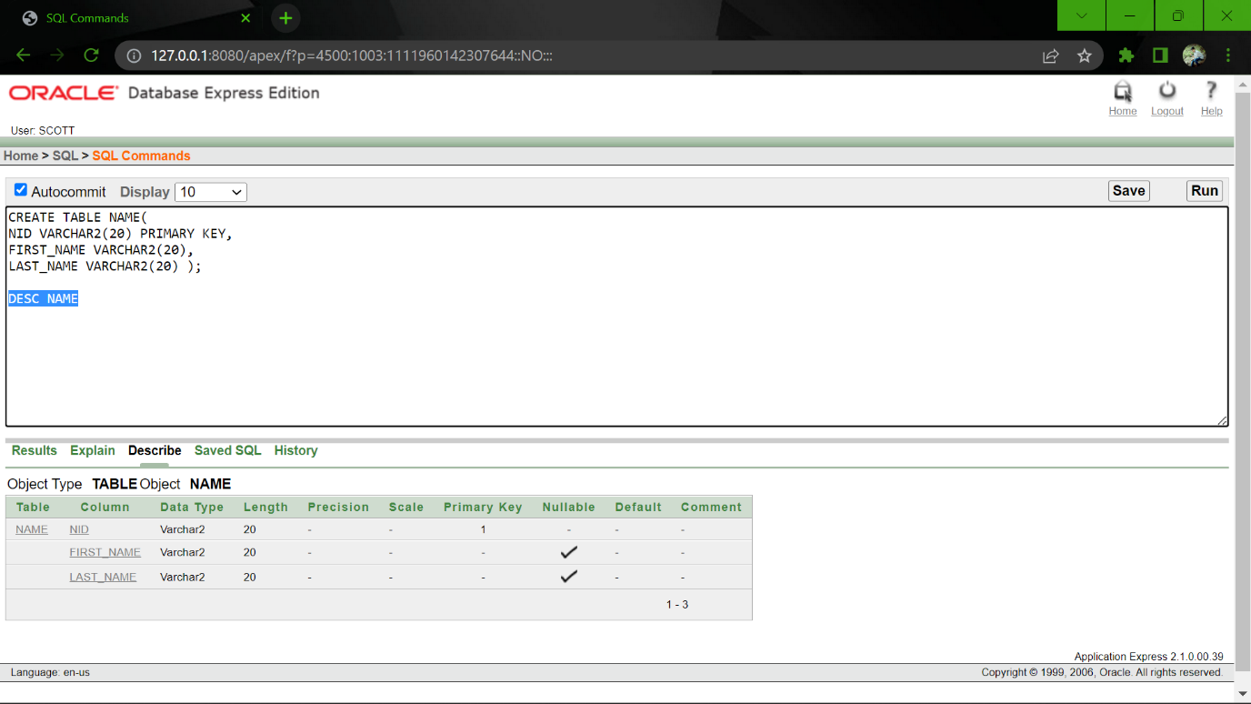

**DEPARTMENT TABLE:**

CREATE TABLE DEPARTMENT(

DEPT_CODE VARCHAR2(20) PRIMARY KEY,

DEPT_NAME VARCHAR2(20),

SALARY VARCHAR2(20) );

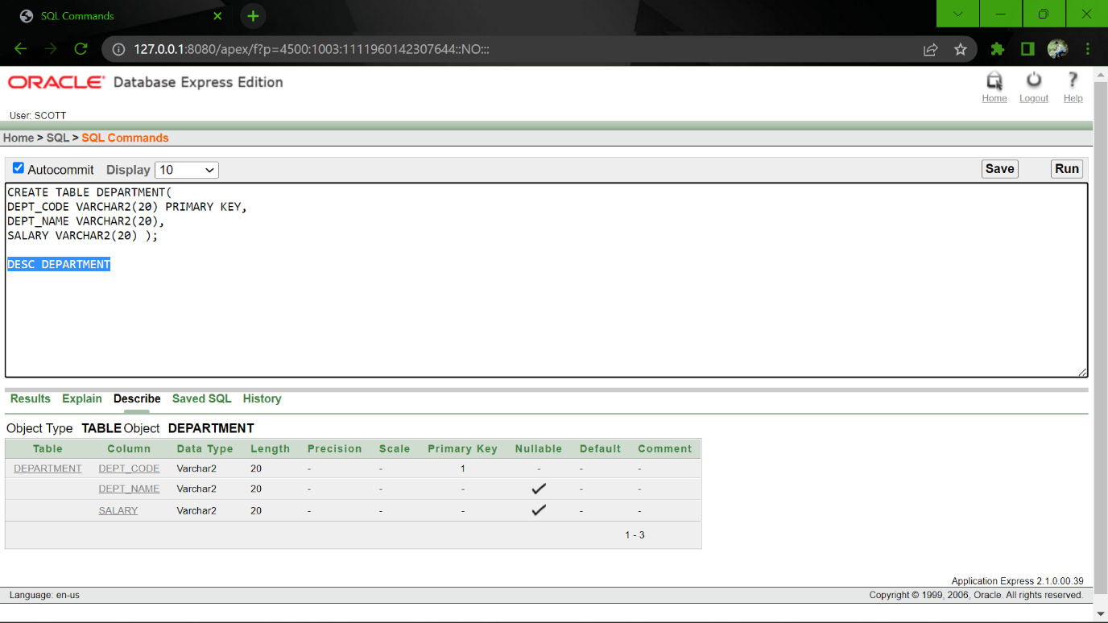DESC DEPARTMENT

**EMPLOYEE TABLE:**

CREATE TABLE EMPLOYEE(

E_ID NUMBER(10) PRIMARY KEY,

CITY VARCHAR2(20),

SALARY VARCHAR2(20),

DEPT_CODE REFERENCES DEPARTMENT,

PHONE_ID REFERENCES PHONE,

NID REFERENCES NAME );

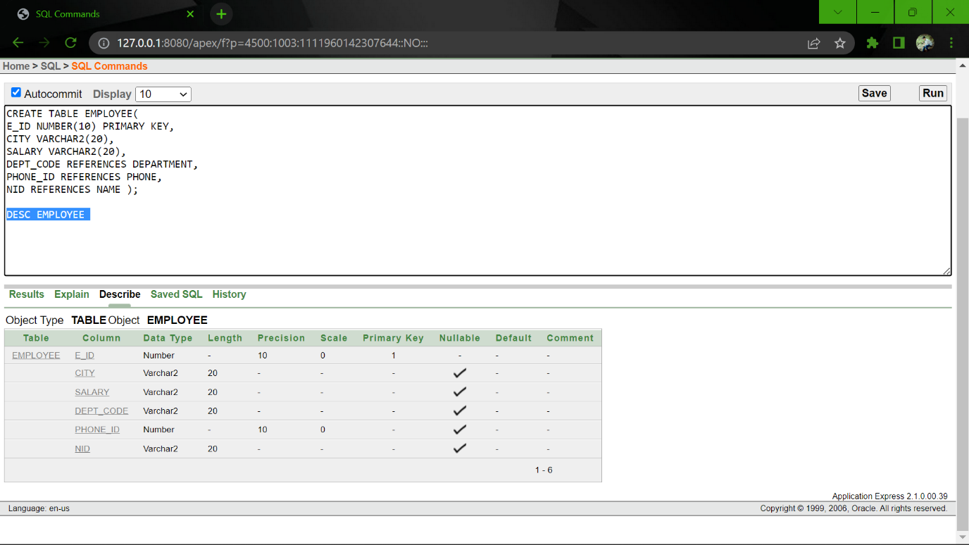DESC EMPLOYEE

**ADDRESS TABLE:**

CREATE TABLE ADDRESS(

ADDRESS_ID NUMBER(10) PRIMARY KEY,

HOUSE_NO VARCHAR2(20),

STREET_NO VARCHAR2(20),

CITY VARCHAR2(20) );

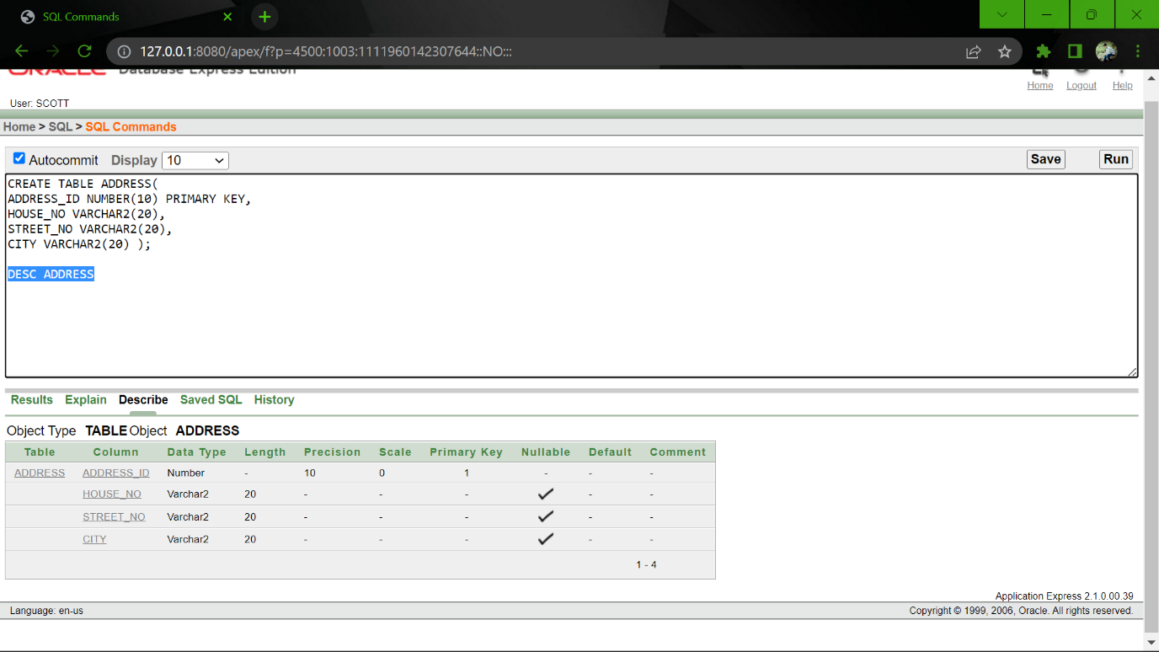DESC ADDRESS

**HOUSE OWNER TABLE:**

CREATE TABLE HOUSE_OWNER(

HO_ID NUMBER(10) PRIMARY KEY,

EMAIL VARCHAR2(20),

NID REFERENCES NAME,

PHONE_ID REFERENCES PHONE,

ADDRESS_ID REFERENCES ADDRESS );

DESC HOUSE_OWNER

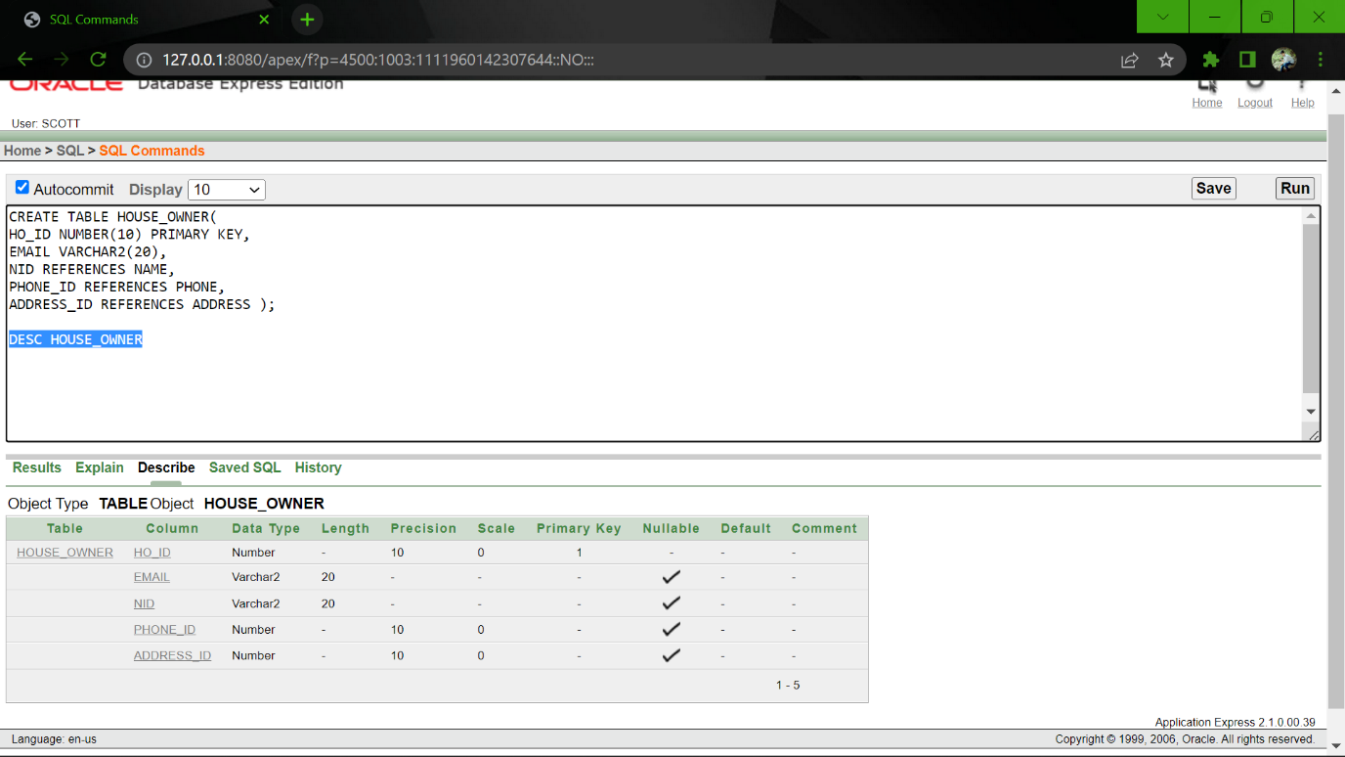

**CUSTOMER TABLE:**

CREATE TABLE CUSTOMER(

CU_ID NUMBER(10) PRIMARY KEY,

EMAIL VARCHAR2(20),

CITY VARCHAR2(20),

NID REFERENCES NAME,

PHONE_ID REFERENCES PHONE );

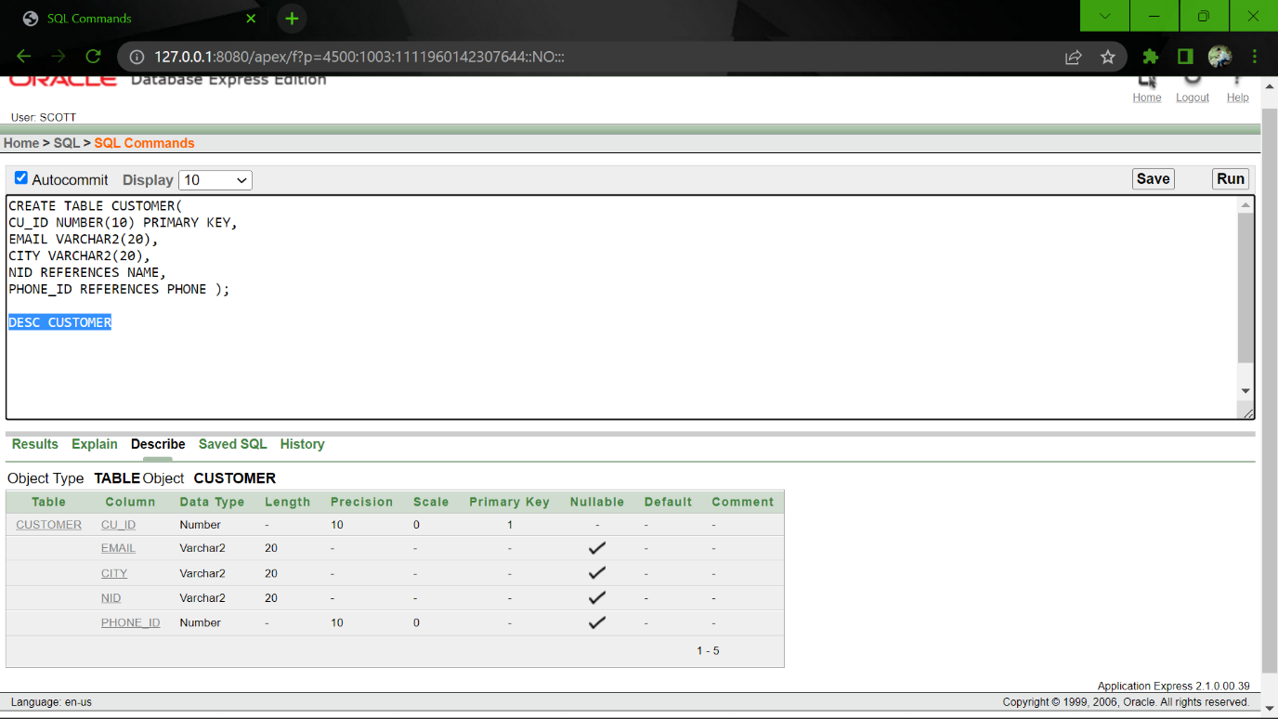DESC CUSTOMER

**PAYMENT TABLE:**

CREATE TABLE PAYMENT(

PAYMENT_ID NUMBER(10) PRIMARY KEY,

PRICE VARCHAR2(20),

PAYMENT_METHOD VARCHAR2(20) );

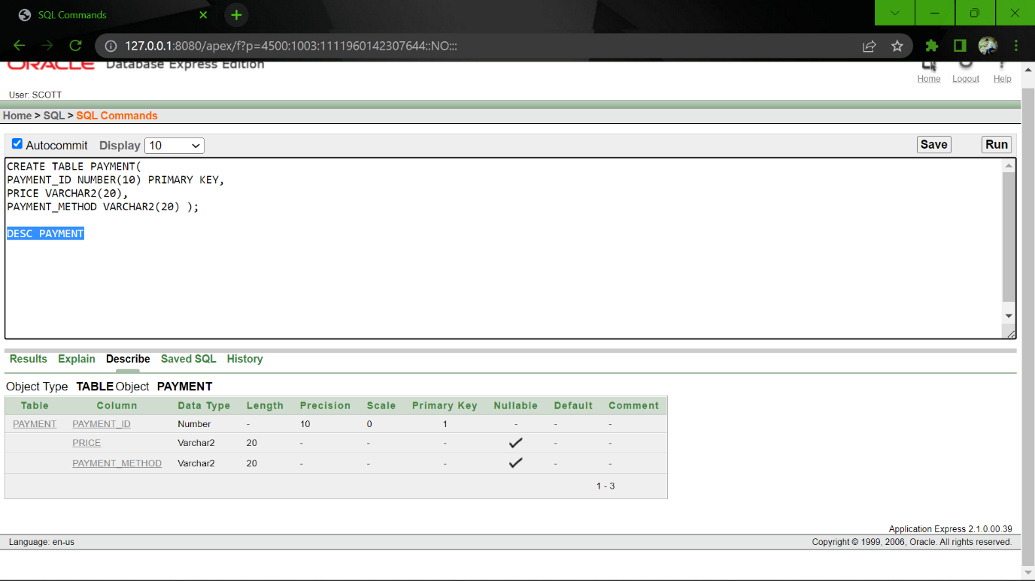DESC PAYMENT

**MECH TABLE:**

CREATE TABLE MECH(

MECH_ID NUMBER(10) PRIMARY KEY,

BATHROOM_NO NUMBER(10),

BED_NO NUMBER(10),

SUBLET_NO NUMBER(10) );

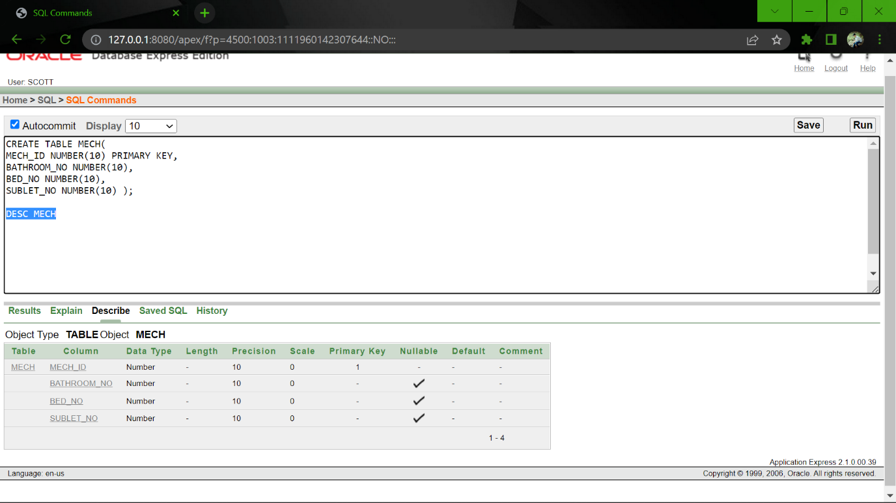DESC MECH

**SUBLET TABLE:**

CREATE TABLE SUBLET(

SUBLET_ID NUMBER(10) PRIMARY KEY,

EMAIL VARCHAR2(20),

CITY VARCHAR2(20),

NID REFERENCES NAME,

MECH_ID REFERENCES MECH,

PHONE_ID REFERENCES PHONE );

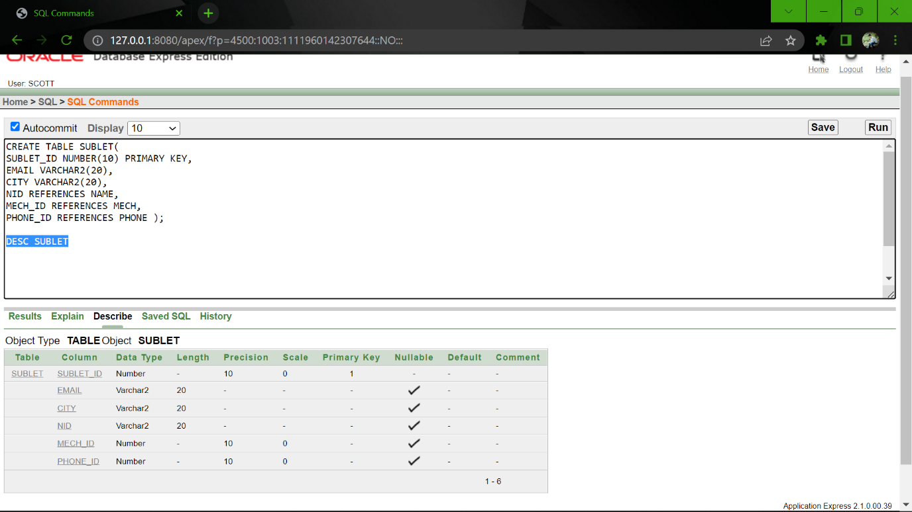DESC SUBLET

**RENTAL ITEM TABLE:**

CREATE TABLE RENTAL_ITEM(

RI_ID NUMBER(10) PRIMARY KEY,

RI_NAME VARCHAR2(20),

HO_ID REFERENCES HOUSE_OWNER );

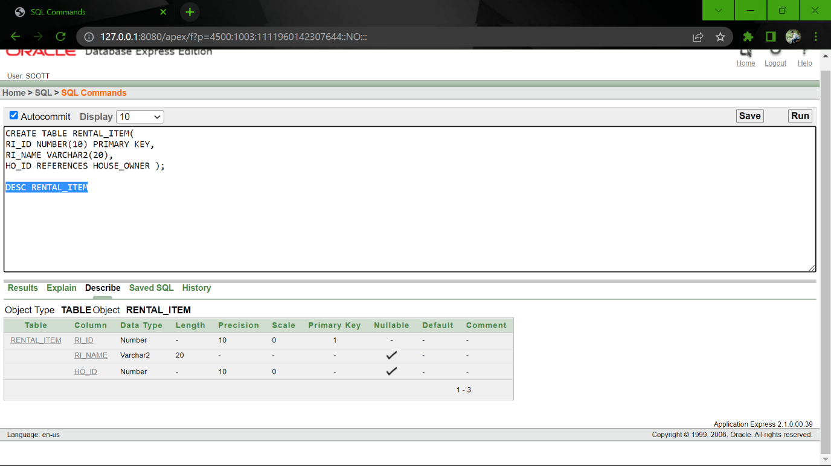DESC RENTAL_ITEM

**FAMILY HOUSE TABLE:**

CREATE TABLE FAMILY_HOUSE(

FH_ID NUMBER(10) PRIMARY KEY,

SECUIRUTY VARCHAR2(20),

BED_NO NUMBER(10),

LIFT_FACILITY VARCHAR2(20),

ADDRESS_ID REFERENCES ADDRESS );

DESC FAMILY_HOUSE

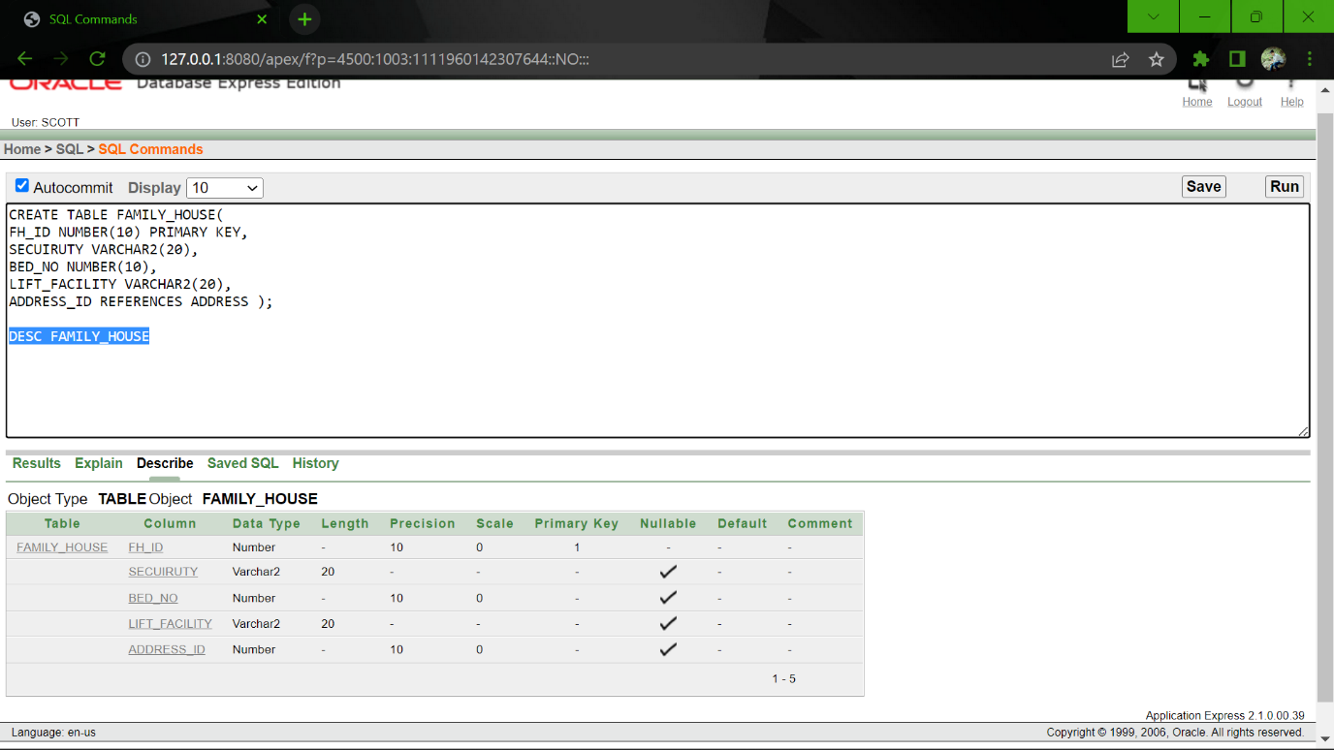

**OFFICE SPACE TABLE:**

CREATE TABLE OFFICE_SPACE(

OS_ID NUMBER(10) PRIMARY KEY,

OFFICE_SIZE VARCHAR2(20),

SECUIRUTY VARCHAR2(20),

LIFT_FACILITY VARCHAR2(20),

GARAGE_FACILITY VARCHAR2(20),

ADDRESS_ID REFERENCES ADDRESS );

DESC OFFICE_SPACE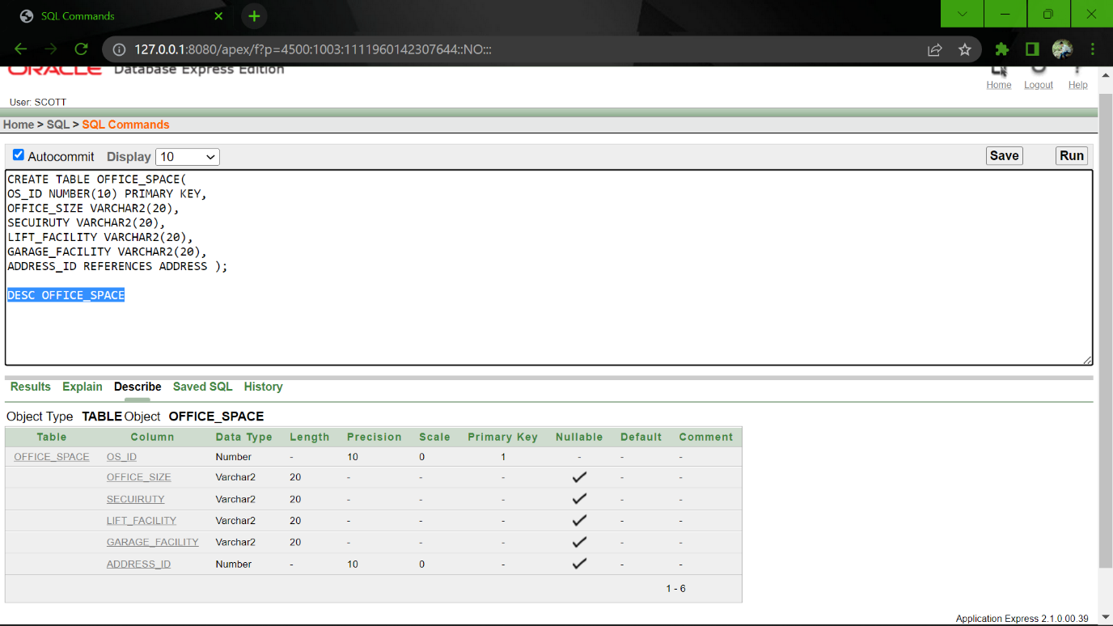

**Table Insertion:**

**PHONE TABLE:**

1.

INSERT INTO PHONE VALUES( '01','+8801712345678');

INSERT INTO PHONE VALUES( '02','+8801712345679');

INSERT INTO PHONE VALUES( '03','+8801712345680');

INSERT INTO PHONE VALUES( '04','+8801712345681');

INSERT INTO PHONE VALUES( '05','+8801712345681');

INSERT INTO PHONE VALUES( '06','+8801612345682');

INSERT INTO PHONE VALUES( '07','+8801612345683');

INSERT INTO PHONE VALUES( '08','+8801612345684');

INSERT INTO PHONE VALUES( '09','+8801612345685');

INSERT INTO PHONE VALUES( '10','+8801612345686');

INSERT INTO PHONE VALUES( '11','+8801312345687');

INSERT INTO PHONE VALUES( '12','+8801312345688');

INSERT INTO PHONE VALUES( '13','+8801312345689');

INSERT INTO PHONE VALUES( '14','+8801312345681');

INSERT INTO PHONE VALUES( '15','+8801312345682');

INSERT INTO PHONE VALUES( '16','+8801912345683');

INSERT INTO PHONE VALUES( '17','+8801912345684');

INSERT INTO PHONE VALUES( '18','+8801912345685');

INSERT INTO PHONE VALUES( '19','+8801912345686');

INSERT INTO PHONE VALUES( '20','+8801912345687');

INSERT INTO PHONE VALUES( '21','+8801918345687');

INSERT INTO PHONE VALUES( '22','+8801312345688');

INSERT INTO PHONE VALUES( '23','+8801312345689');

INSERT INTO PHONE VALUES( '24','+8801312345681');

INSERT INTO PHONE VALUES( '25','+8801312345682');

INSERT INTO PHONE VALUES( '26','+8801912345683');

SELECT *

FROM PHONE

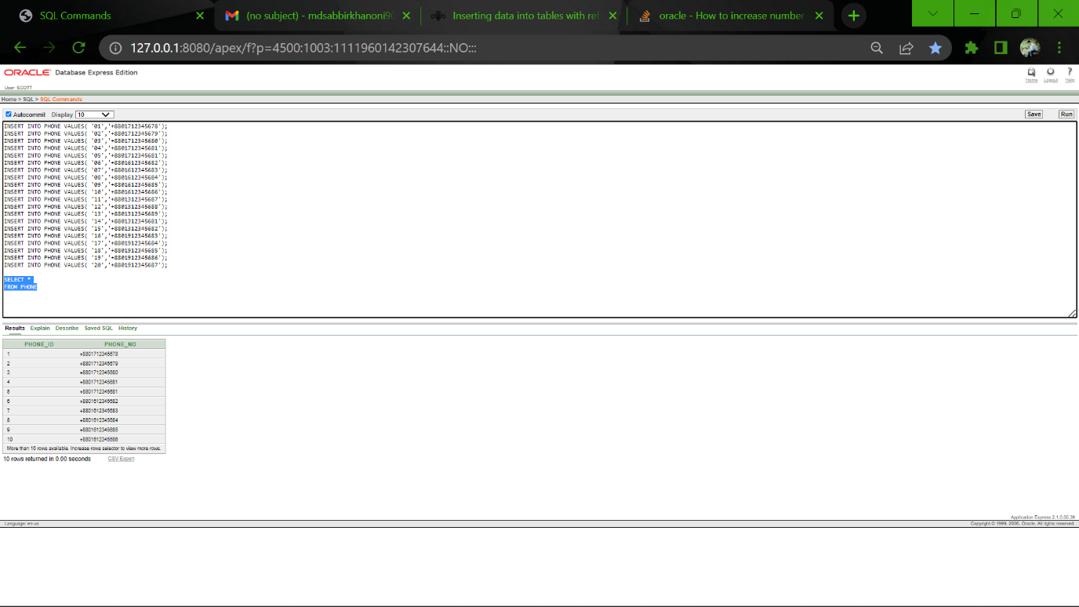

**AUTHORITY TABLE:**

2.

INSERT INTO AUTHORITY VALUES('12345','SWEET HOME RENTAL AGENCY','01');

SELECT *

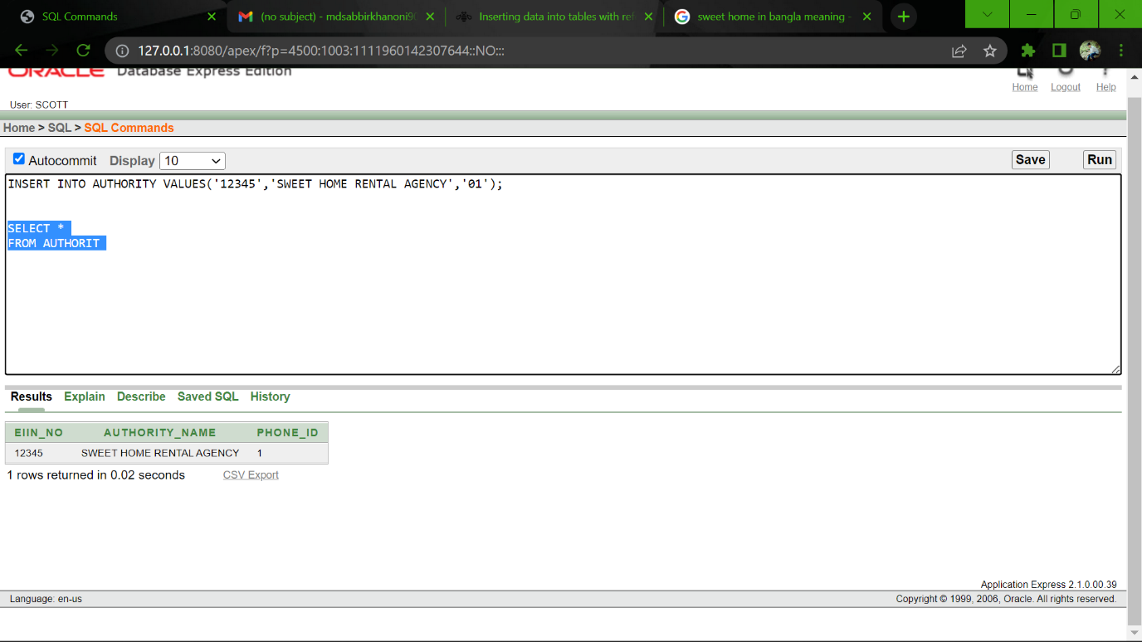FROM AUTHORITY

**NAME TABLE:**

3.

INSERT INTO NAME VALUES('101','MD SABBIR','KHAN');

INSERT INTO NAME VALUES('102','MD AKASH','KHAN');

INSERT INTO NAME VALUES('103','NUR-E HABIB','NURSHED');

INSERT INTO NAME VALUES('104','RAIHANUL','ISLAM');

INSERT INTO NAME VALUES('105','JULKER','NINE');

INSERT INTO NAME VALUES('106','HABIUR','RAHAMAN');

INSERT INTO NAME VALUES('107','SAHADAT','HOSSAIN');

INSERT INTO NAME VALUES('108','SABAB','RAHAMAN');

INSERT INTO NAME VALUES('109','RICKI','SEN');

INSERT INTO NAME VALUES('110','DIPON','BISWAS');

INSERT INTO NAME VALUES('111','MAHADI','KABIR');

INSERT INTO NAME VALUES('112','REZAUL','KARIM');

INSERT INTO NAME VALUES('113','RISI','GUPTA');

INSERT INTO NAME VALUES('114','AQIB','HOWLADER');

INSERT INTO NAME VALUES('115','RISHAD','RAHMAN');

INSERT INTO NAME VALUES('116',RASEDUR ,'RAHAMAN');

INSERT INTO NAME VALUES('117',KHALID ,'HOSSAIN');

INSERT INTO NAME VALUES('118','RIYANTTI','SEN');

INSERT INTO NAME VALUES('119','SIMA','RAHAMAN');

INSERT INTO NAME VALUES('120','PRIYA','BISWAS');

INSERT INTO NAME VALUES('121','MEHEDI','RAHAMAN');

INSERT INTO NAME VALUES('122','REZAUL','SHARIF);

INSERT INTO NAME VALUES('123','RUMPA','KHAN');

INSERT INTO NAME VALUES('124','ISRAT','EVA');

INSERT INTO NAME VALUES('125','RAJU','RAHMAN');

SELECT *

FROM NAME

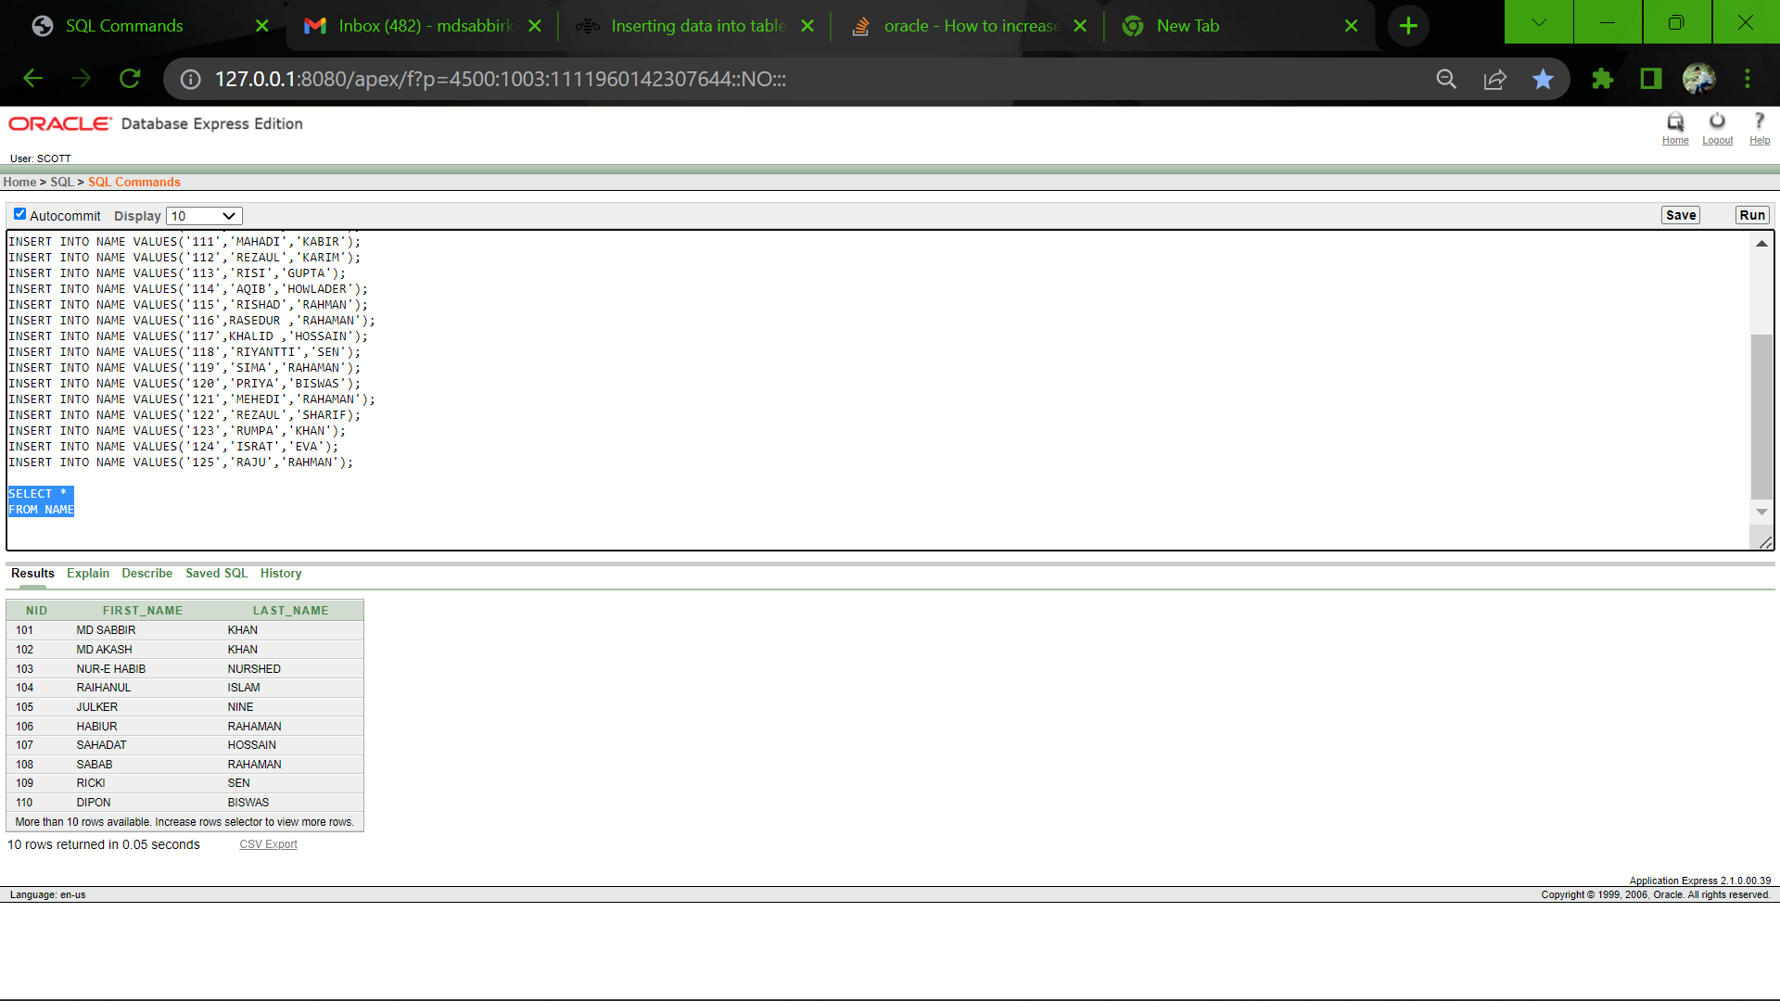

**DEPARTMENT TABLE:**

4.

INSERT INTO DEPARTMENT VALUES('8801','FINANCE','10000');

INSERT INTO DEPARTMENT VALUES('8802','ACCOUNTING','15000');

INSERT INTO DEPARTMENT VALUES('8803','MARKETING','20000');

INSERT INTO DEPARTMENT VALUES('8804','OPERATION MANAGEMENT','25000');

INSERT INTO DEPARTMENT VALUES('8805','SOFTWARE MANAGEMENT','30000');

SELECT *

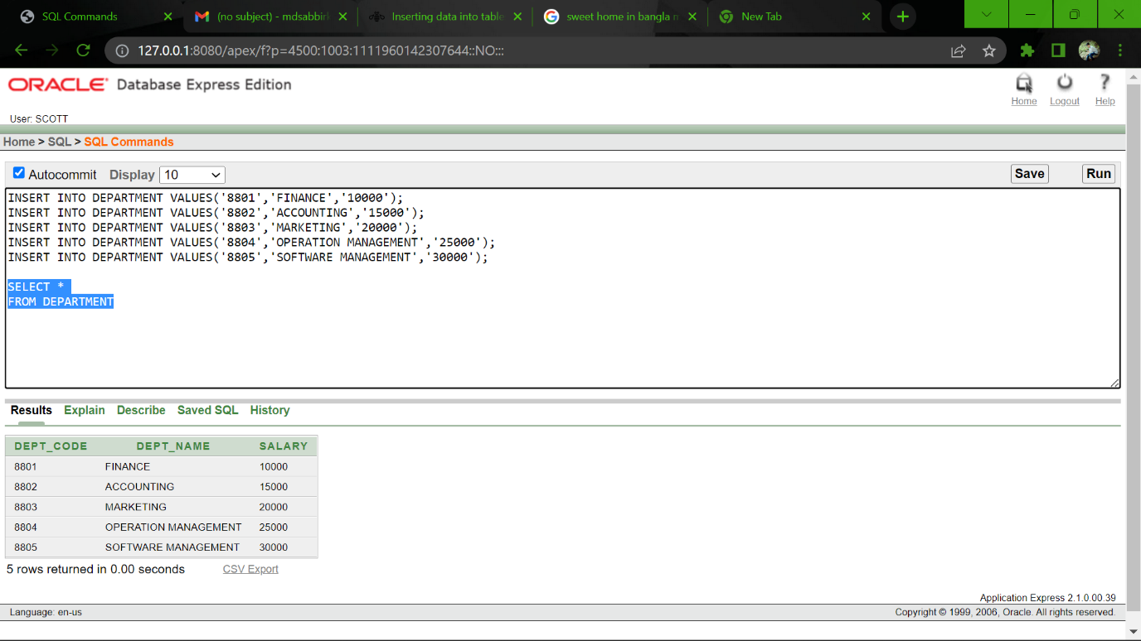FROM DEPARTMENT

**EMPLOYEE** **TABLE:**

5.

INSERT INTO EMPLOYEE VALUES('2201','DHAKA','10000','8801','07','106');

INSERT INTO EMPLOYEE VALUES('2202','DHAKA','10000','8802','08','107');

INSERT INTO EMPLOYEE VALUES('2203','DHAKA','10000','8803','09','108');

INSERT INTO EMPLOYEE VALUES('2204','DHAKA','10000','8804','10','109');

INSERT INTO EMPLOYEE VALUES('2205','DHAKA','10000','8805','11','110');

SELECT *

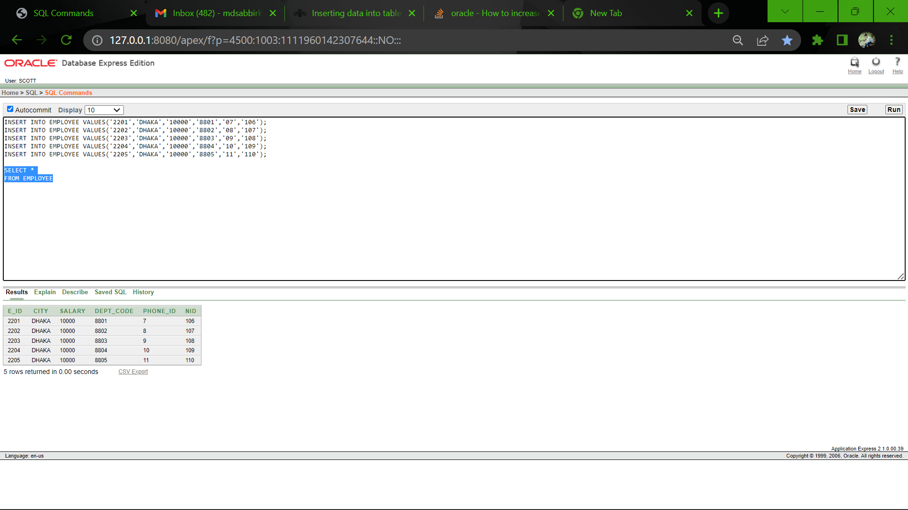FROM EMPLOYEE

**ADDRESS TABLE:**

6.

INSERT INTO ADDRESS VALUES('1000','314','612','CTG');

INSERT INTO ADDRESS VALUES('1001','317','125','DHAKA');

INSERT INTO ADDRESS VALUES('1002','312','516','COXSBAZAR');

INSERT INTO ADDRESS VALUES('1003','316','197','PEKUA');

INSERT INTO ADDRESS VALUES('1004','315','188','KULNA');

INSERT INTO ADDRESS VALUES('1005','344','172','CTG');

INSERT INTO ADDRESS VALUES('1006','327','165','DHAKA');

INSERT INTO ADDRESS VALUES('1007',352','156','COXSBAZAR');

INSERT INTO ADDRESS VALUES('1008','516,'147','PEKUA');

INSERT INTO ADDRESS VALUES('1009','815','138','KULNA');

INSERT INTO ADDRESS VALUES('1010','214','122','CTG');

INSERT INTO ADDRESS VALUES('1011','717','418','DHAKA');

INSERT INTO ADDRESS VALUES('1012','212','116','COXSBAZAR');

INSERT INTO ADDRESS VALUES('1013','916','117','PEKUA');

INSERT INTO ADDRESS VALUES('1014','515','138','KULNA');

INSERT INTO ADDRESS VALUES('1015','214','162','CTG');

INSERT INTO ADDRESS VALUES('1016','817','115','DHAKA');

INSERT INTO ADDRESS VALUES('1017','352','116','COXSBAZAR');

INSERT INTO ADDRESS VALUES('1018','326','118','PEKUA');

INSERT INTO ADDRESS VALUES('1019','385','119','KULNA');

INSERT INTO ADDRESS VALUES('1020','395','117','KULNA');

SELECT *

FROM ADDRESS

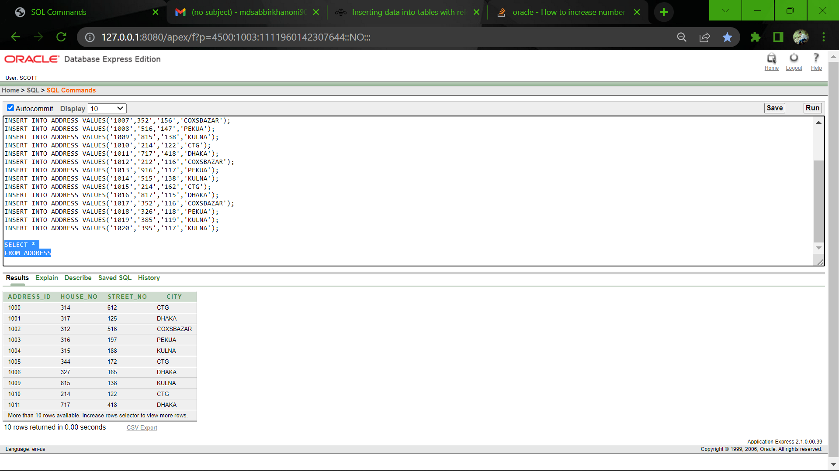

**HOUSE OWNER TABLE:**

7.

INSERT INTO HOUSE_OWNER VALUES('884601','sajibul1@gamil.com','111','12','1000');

INSERT INTO HOUSE_OWNER VALUES('884602','raihanul2@gamil.com','112','13','1001');

INSERT INTO HOUSE_OWNER VALUES('884603','mdsakib3@gamil.com','113','14','1002');

INSERT INTO HOUSE_OWNER VALUES('884604','mdabdul4@gamil.com','114','15','1003');

INSERT INTO HOUSE_OWNER VALUES('884605','oniislam5@gamil.com','115','16','1004');

SELECT *

FROM HOUSE_OWNER

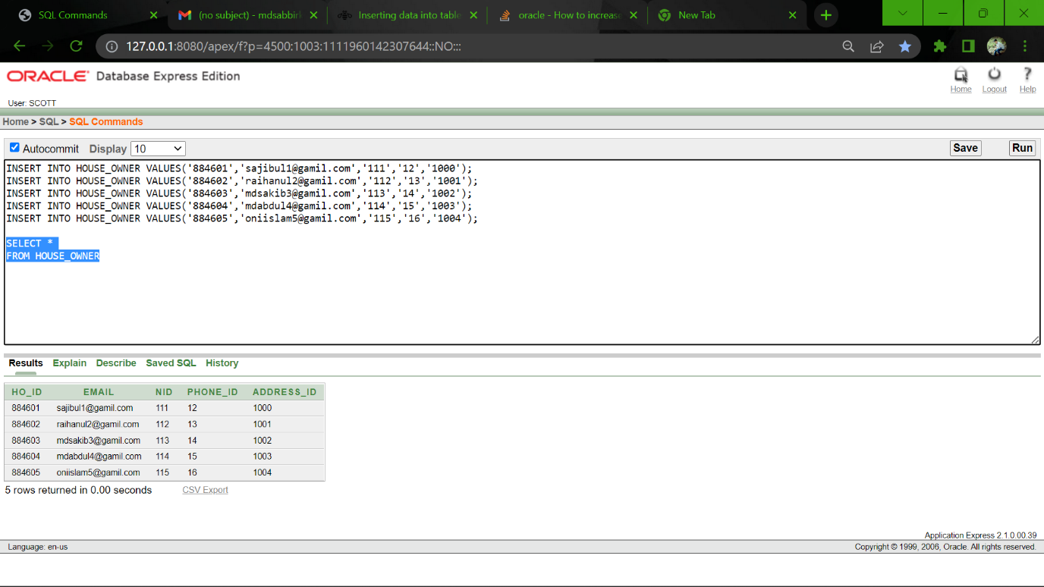

**CUSTOMER TABLE:**

8.

INSERT INTO CUSTOMER VALUES('884701','abcd1@gamil.com','DHAKA','116','17');

INSERT INTO CUSTOMER VALUES('884702','efgh2@gamil.com','DHAKA','117','18');

INSERT INTO CUSTOMER VALUES('884703','ijkl3@gamil.com','RAJSHAI','118','19');

INSERT INTO CUSTOMER VALUES('884704','mnop4@gamil.com','KHULNA','119','20');

INSERT INTO CUSTOMER VALUES('884705','qrst@gamil.com','BARISHAL','120','21');

SELECT *

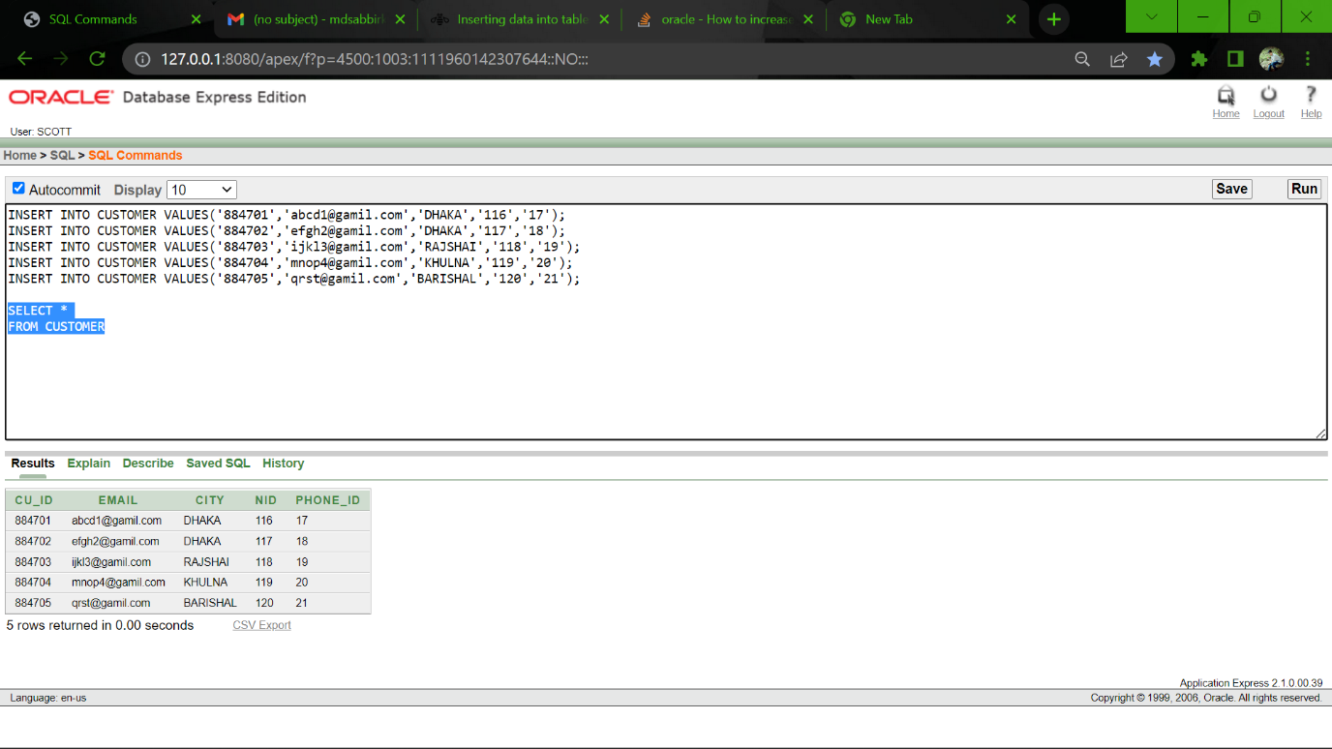FROM CUSTOMER

**PAYMENT TABLE:**

9.

INSERT INTO PAYMENT VALUES( '7701','10000','BKASH');

INSERT INTO PAYMENT VALUES( '7702','12000','NAGAD');

INSERT INTO PAYMENT VALUES( '7703','14000','ROCKET');

INSERT INTO PAYMENT VALUES( '7704','16000','UPAY');

INSERT INTO PAYMENT VALUES( '7705','18000','SURECASH');

SELECT *

FROM PAYMENT

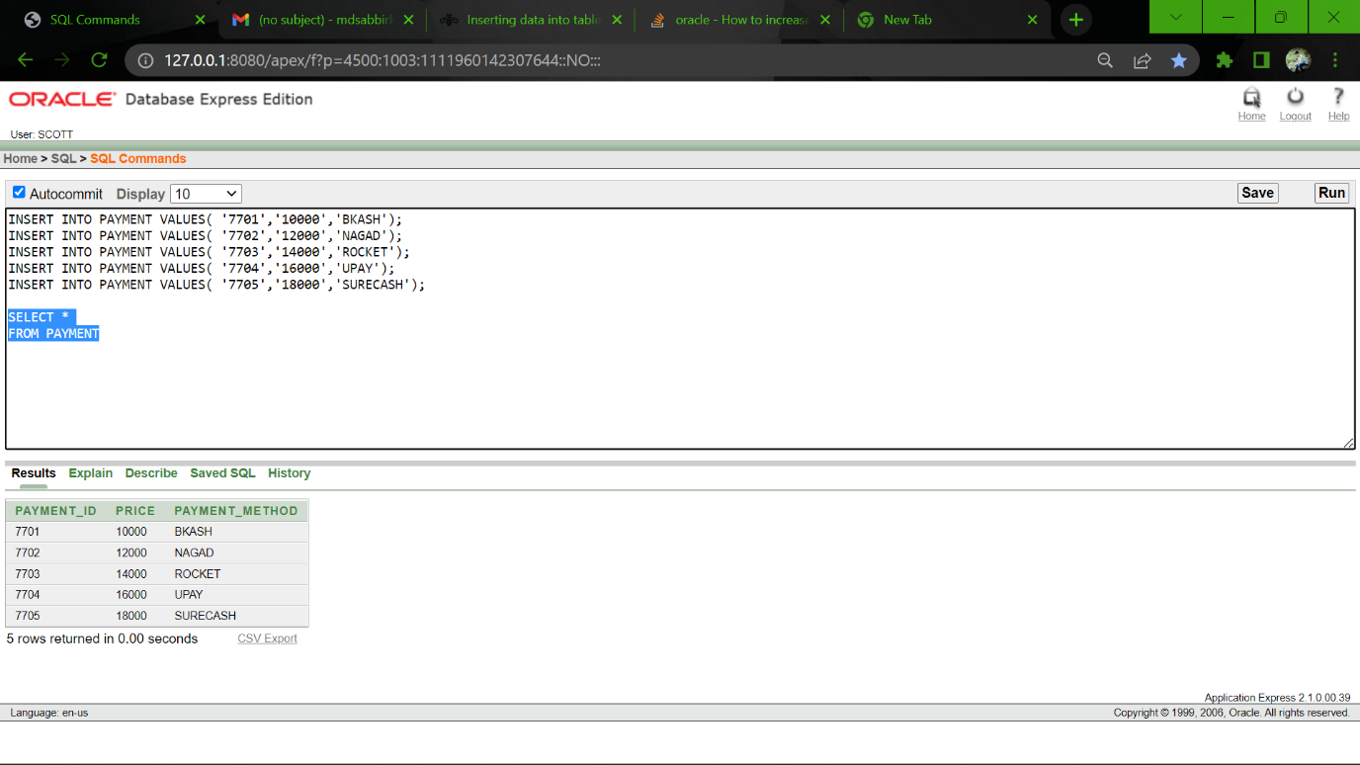

**MECH TABLE:**

10.

INSERT INTO MECH VALUES('88460011','02','03','02');

INSERT INTO MECH VALUES('88460012','01','02','03');

INSERT INTO MECH VALUES('88460013','02','02','01');

INSERT INTO MECH VALUES('88460014','01','02','04');

INSERT INTO MECH VALUES('88460015','02','03','05');

SELECT *

FROM MECH

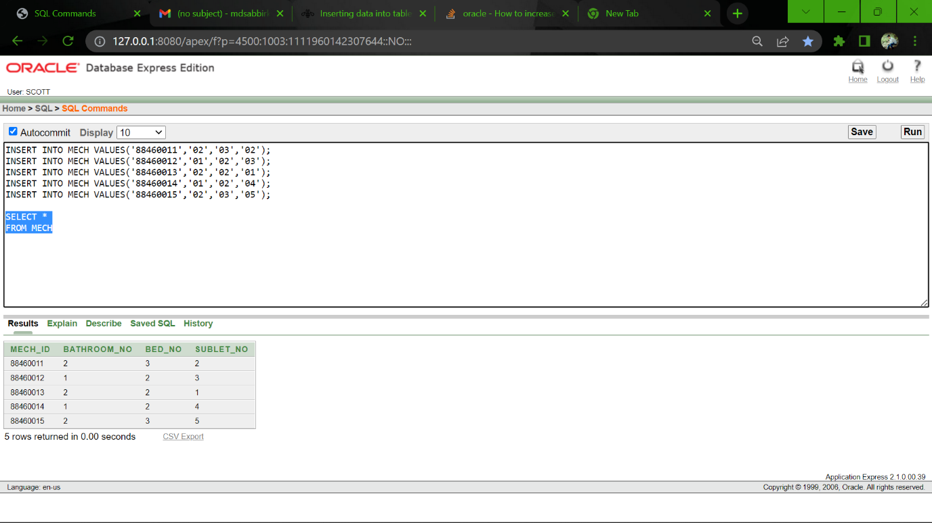

**SUBLET TABLE:**

11.

INSERT INTO SUBLET VALUES('8846001001','xyxyxy@gamil.com','CTG','121','88460011','22');

INSERT INTO SUBLET VALUES('8846001002','ababab01@gamil.com','DHAKA','122','88460012','23');

INSERT INTO SUBLET VALUES('8846001003','acacac02@gamil.com','KULNA','123','88460013','24');

INSERT INTO SUBLET VALUES('8846001004','islam03@gamil.com','RAJUK','124','88460014','25');

INSERT INTO SUBLET VALUES('8846001005','raihan04@gamil.com','COXSBAZAR','125','88460015','26');

SELECT *

FROM SUBLET

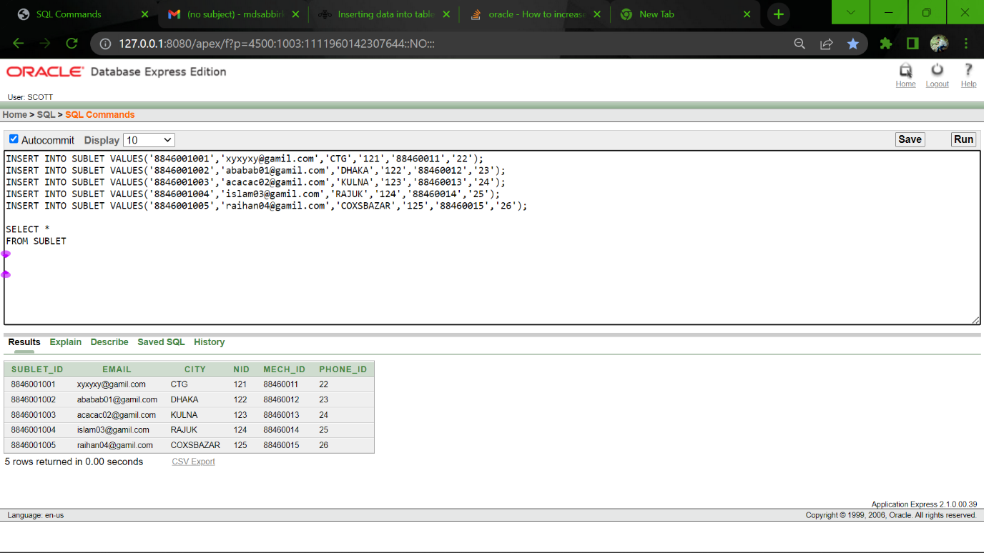

**RENTAL ITEM TABLE:**

12.

INSERT INTO RENTAL_ITEM VALUES('88460501','FAMILY HOUSE','884601');

INSERT INTO RENTAL_ITEM VALUES('88460502','OFFICE SPACE','884602');

INSERT INTO RENTAL_ITEM VALUES('88460503','BACHELOR MACH','884603');

SELECT *

FROM RENTAL_ITEM

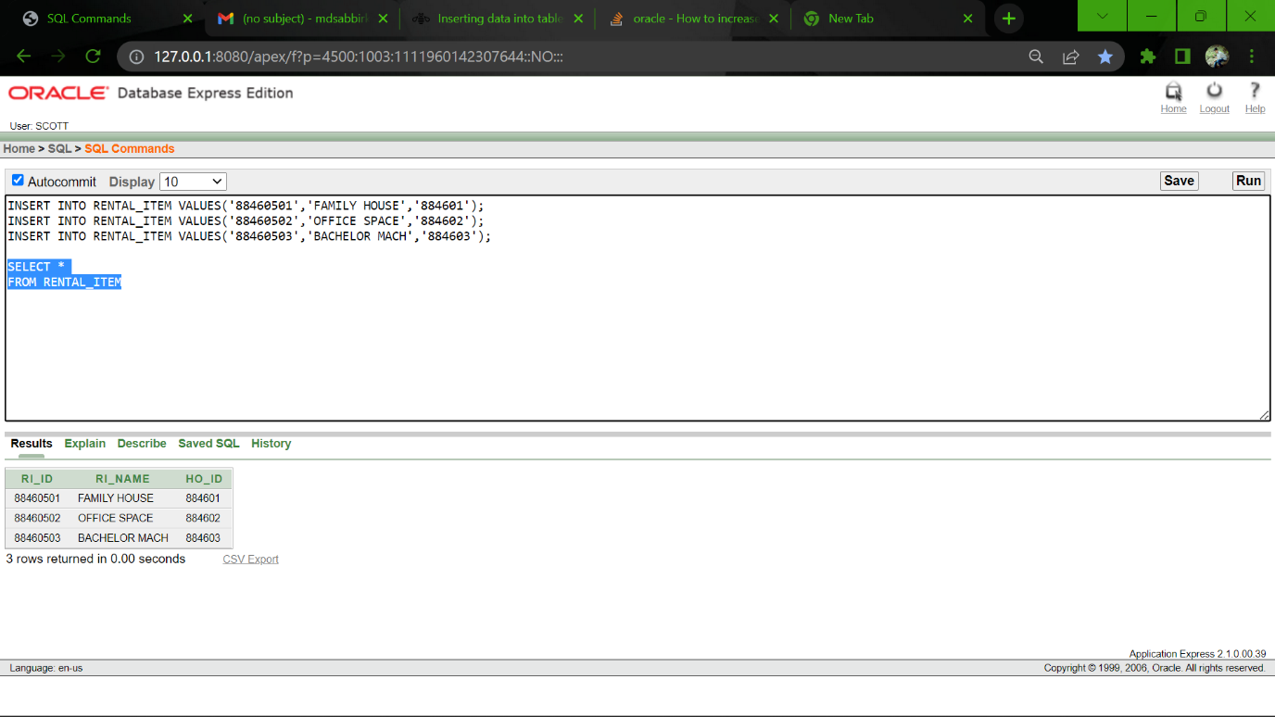

**FAMILY HOUSE TABLE:**

13.

INSERT INTO FAMILY_HOUSE VALUES('88460111','YES','01','YES','1005');

INSERT INTO FAMILY_HOUSE VALUES('88460112','YES','02','NO','1006');

INSERT INTO FAMILY_HOUSE VALUES('88460113','YES','03','YES','1007');

INSERT INTO FAMILY_HOUSE VALUES('88460114','NO','04','NO','1008');

INSERT INTO FAMILY_HOUSE VALUES('88460115','NO','05','NO','1009');

SELECT *

FROM FAMILY_HOUSE

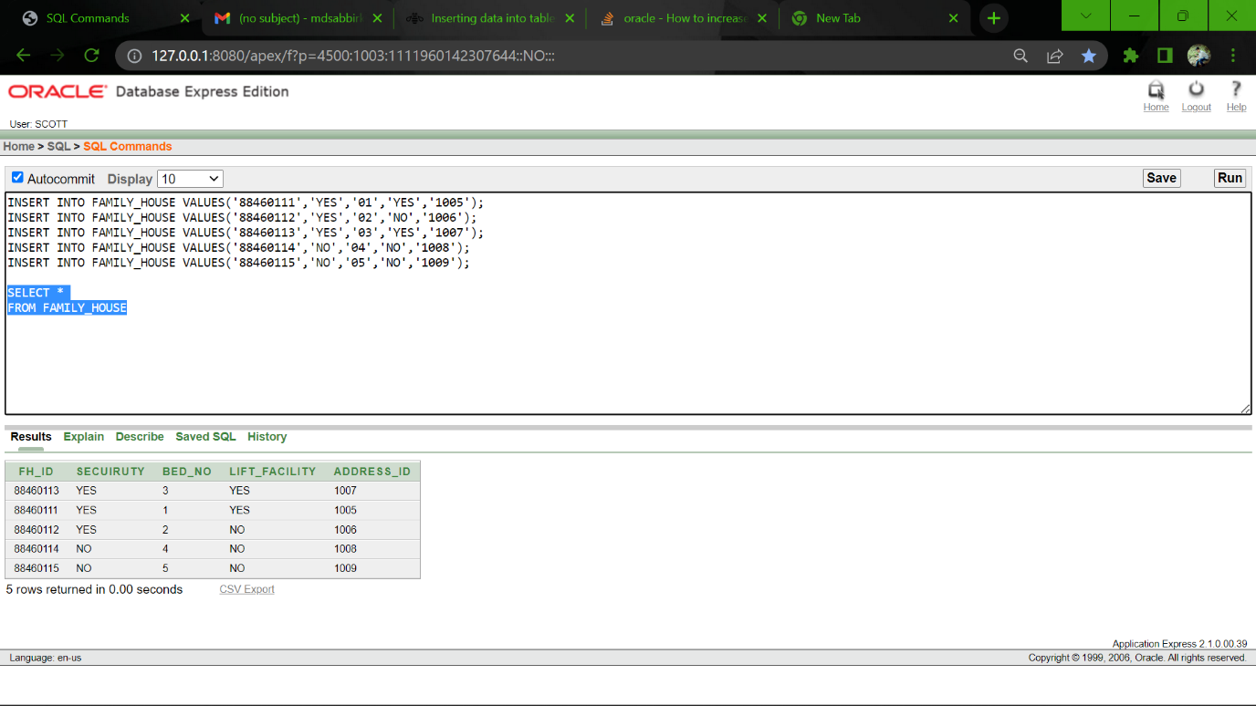

**OFFICE SPACE TABLE:**

14.

INSERT INTO OFFICE_SPACE VALUES('88460211','2440*2400','YES','YES','YES','1010');

INSERT INTO OFFICE_SPACE VALUES('88460212','2440*1600','YES','YES','YES','1011');

INSERT INTO OFFICE_SPACE VALUES('88460213','2440*1800','NO','YES','NO','1012');

INSERT INTO OFFICE_SPACE VALUES('88460214','2000*2000','YES','YES','YES','1013');

INSERT INTO OFFICE_SPACE VALUES('88460215','1600*1600','YES','YES','YES','1014');

SELECT *

FROM OFFICE_SPACE

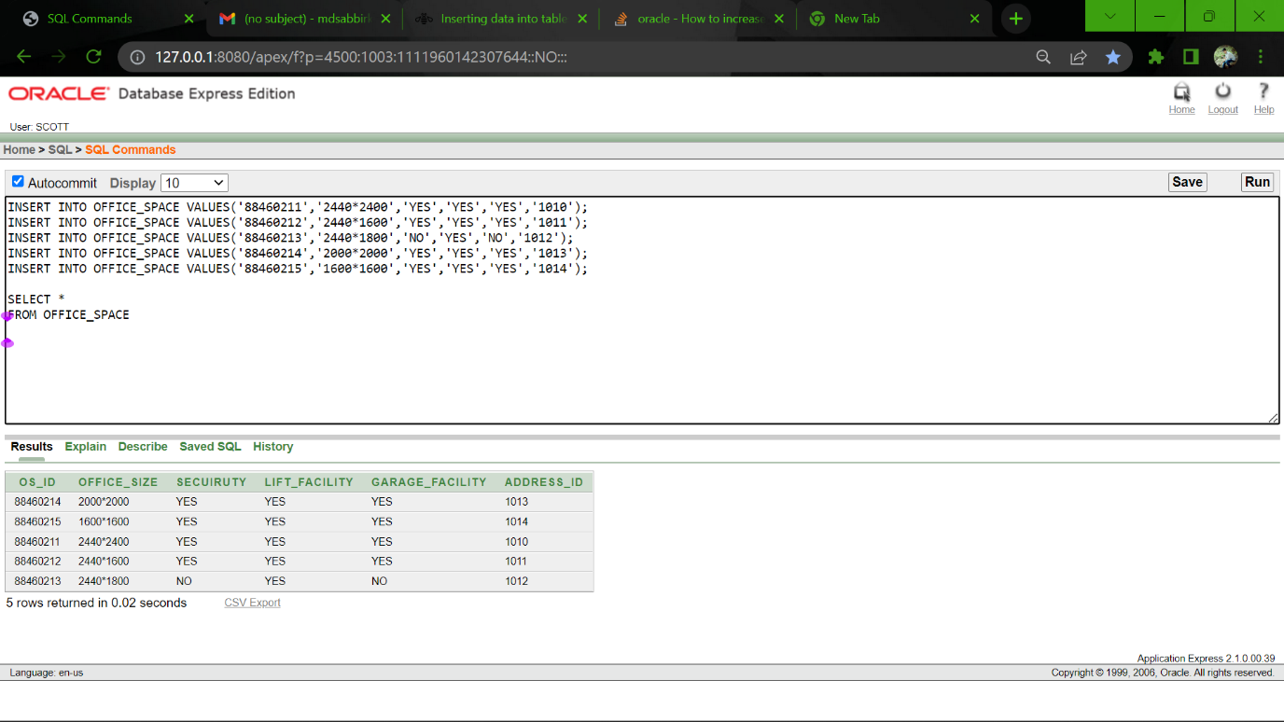

**Sequence:**

1.

CREATE SEQUENCE PHONE_ID_SEQ

MINVALUE 1

MAXVALUE 100

START WITH 1

INCREMENT BY 1

NOCACHE;

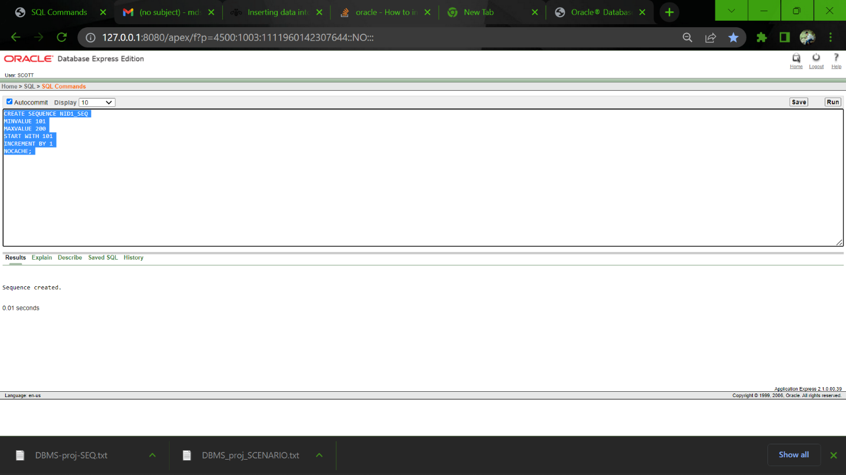

2.

CREATE SEQUENCE NID1_SEQ

MINVALUE 101

MAXVALUE 200

START WITH 101

INCREMENT BY 1

NOCACHE;

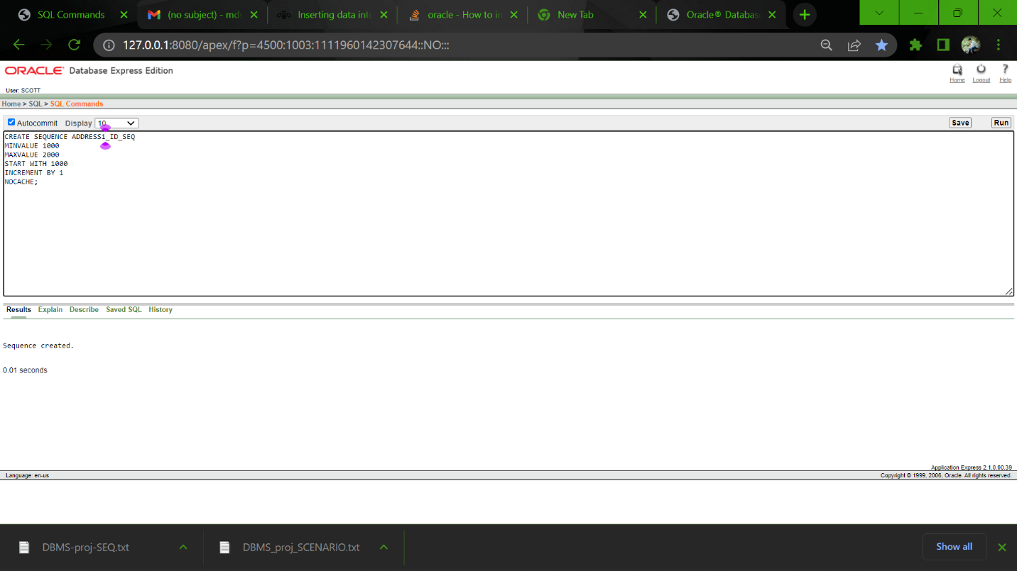

3.

CREATE SEQUENCE ADDRESS1_ID_SEQ

MINVALUE 1000

MAXVALUE 2000

START WITH 1000

INCREMENT BY 1

NOCACHE;

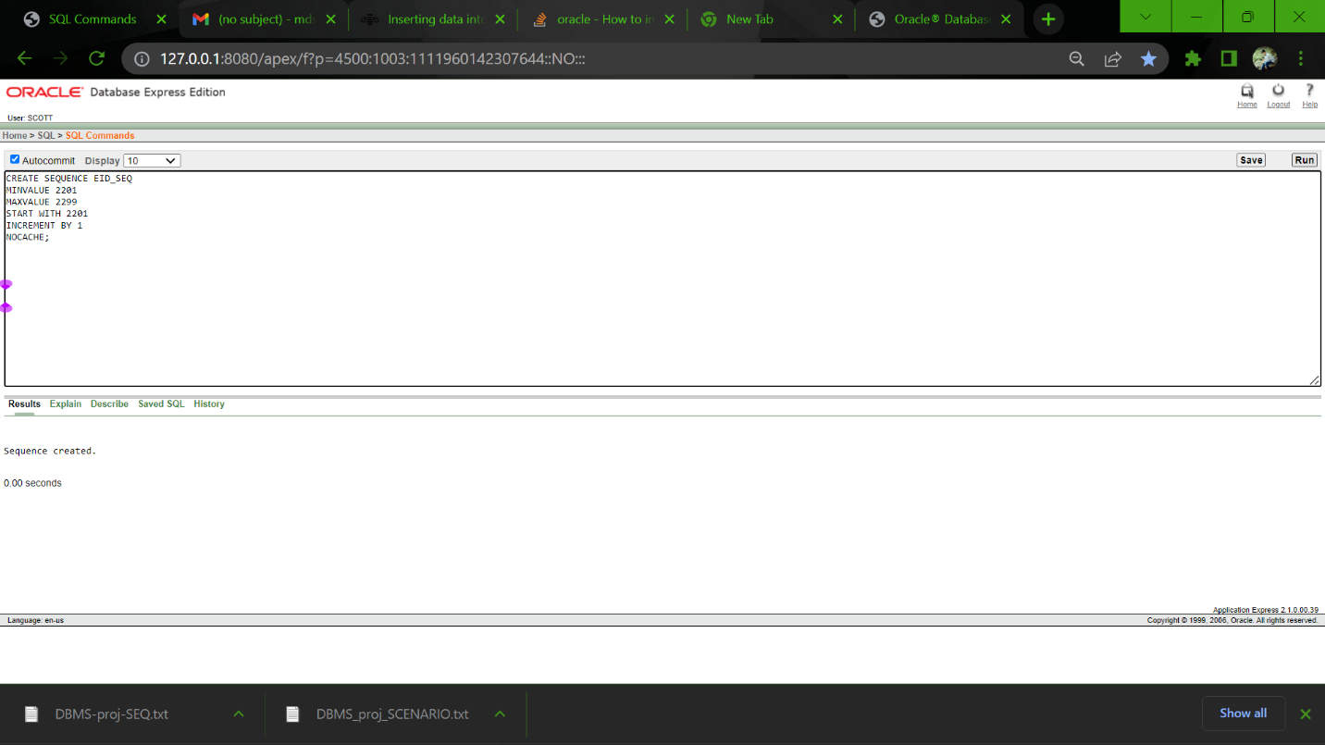

4.

CREATE SEQUENCE EID_SEQ

MINVALUE 2201

MAXVALUE 2299

START WITH 2201

INCREMENT BY 1

NOCACHE;

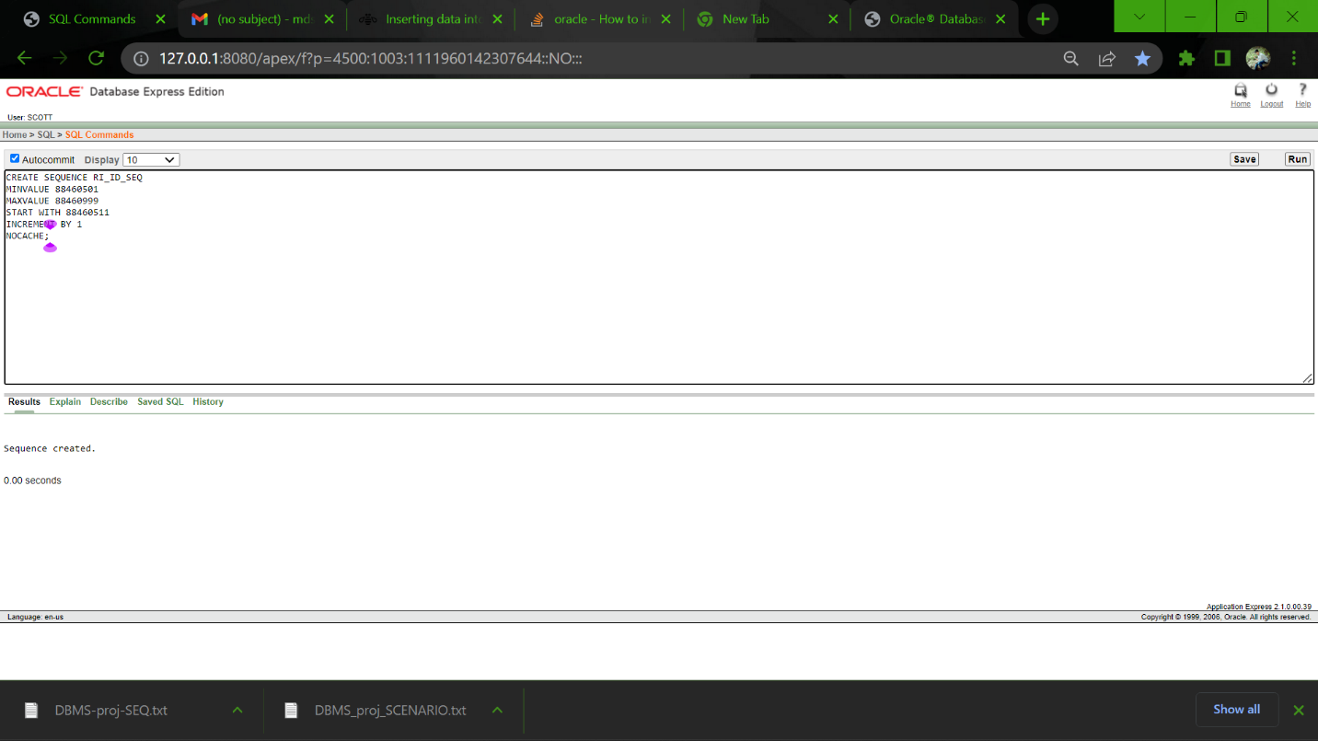

5.

CREATE SEQUENCE DEPTCODE_SEQ

MINVALUE 8801

MAXVALUE 8820

START WITH 8801

INCREMENT BY 1

NOCACHE;

6.

CREATE SEQUENCE HO_ID_SEQ

MINVALUE 884601

MAXVALUE 884699

START WITH 884601

INCREMENT BY 1

NOCACHE;

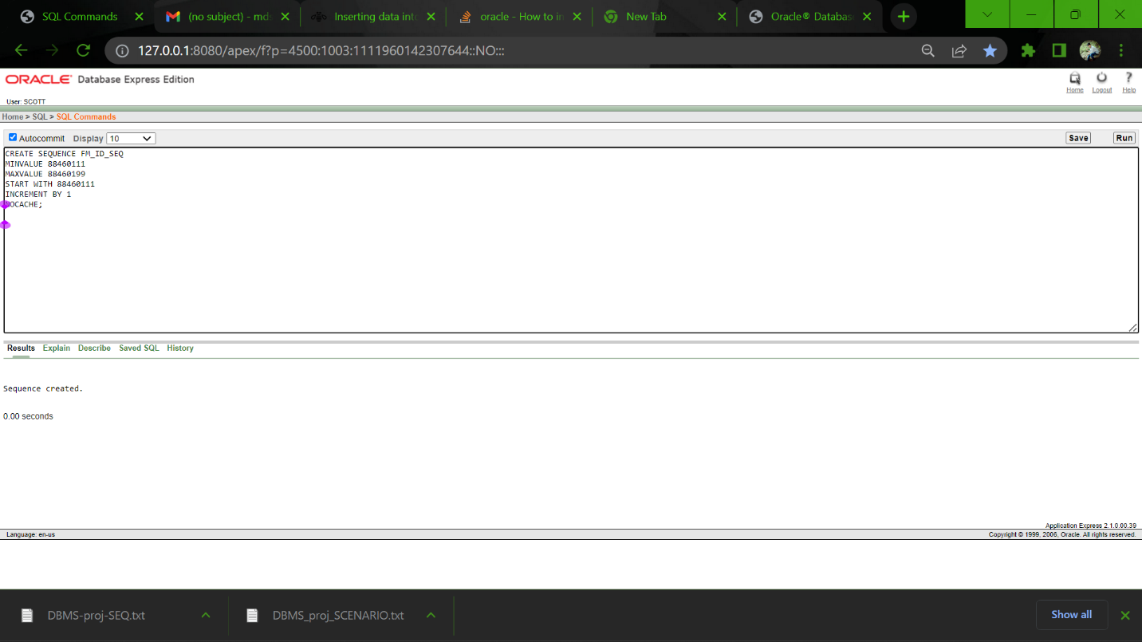

7.

CREATE SEQUENCE CU_ID_SEQ

MINVALUE 884701

MAXVALUE 884799

START WITH 884701

INCREMENT BY 1

NOCACHE;

8.

CREATE SEQUENCE PAYMENT_ID_SEQ

MINVALUE 7701

MAXVALUE 7799

START WITH 7701

INCREMENT BY 1

NOCACHE;

9.

CREATE SEQUENCE MECH_ID_SEQ

MINVALUE 88460011

MAXVALUE 88460099

START WITH 88460011

INCREMENT BY 1

NOCACHE;

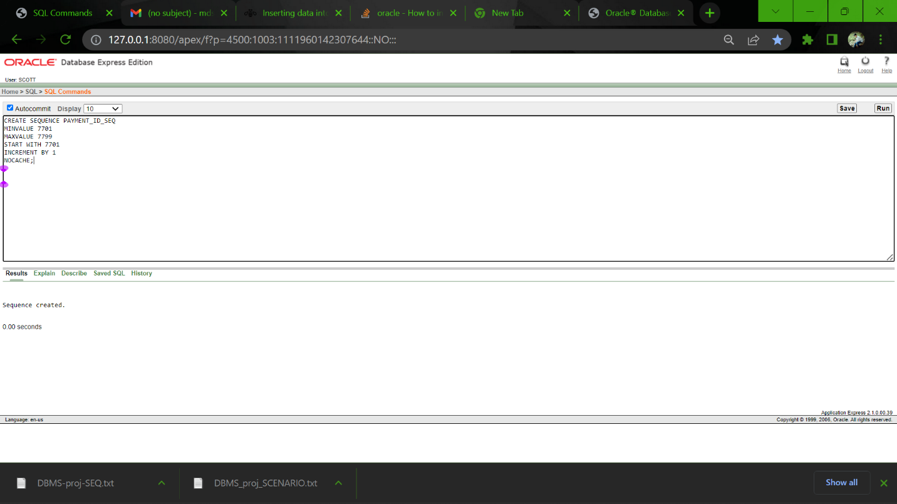

10.

CREATE SEQUENCE SUBLET_ID_SEQ

MINVALUE 8846001001

MAXVALUE 8846001200

START WITH 8846001001

INCREMENT BY 1

NOCACHE;

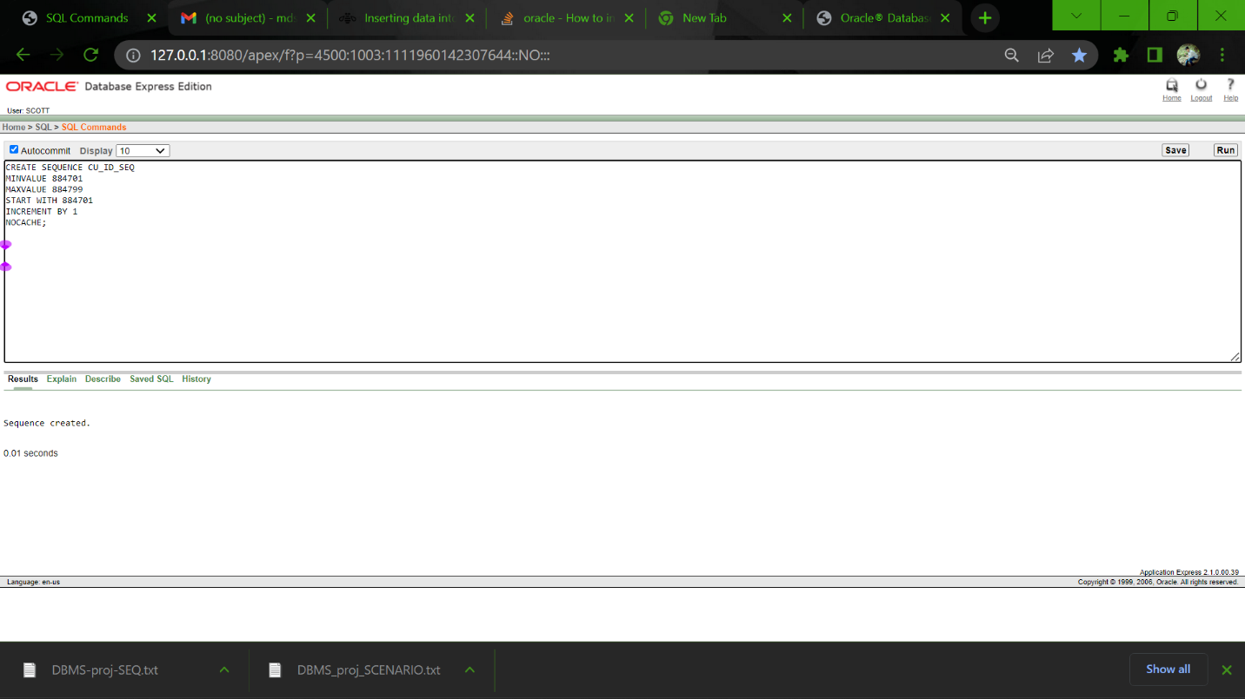

11.

CREATE SEQUENCE FM_ID_SEQ

MINVALUE 88460111

MAXVALUE 88460199

START WITH 88460111

INCREMENT BY 1

NOCACHE;

12.

CREATE SEQUENCE OS_ID_SEQ

MINVALUE 88460211

MAXVALUE 88460299

START WITH 88460211

INCREMENT BY 1

NOCACHE;

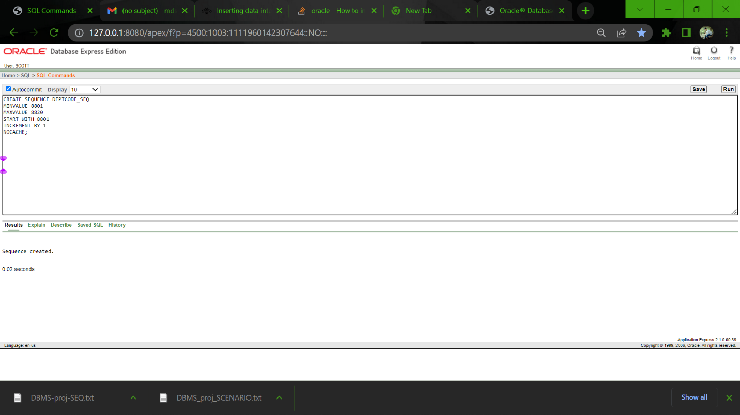

13.

CREATE SEQUENCE RI_ID_SEQ

MINVALUE 88460501

MAXVALUE 88460999

START WITH 88460511

INCREMENT BY 1

NOCACHE;

**Queries:**

1.Show the Employee ID,Salary, First & Last name from Employee and Name Table using Joining

SELECT EMPLOYEE.E_ID,EMPLOYEE.SALARY,NAME.FIRST_NAME, NAME.LAST_NAME

FROM EMPLOYEE,NAME

WHERE EMPLOYEE.NID=NAME.NID;

2. Write a Query to show the Price and Payment-id from Payment Table where the price is greater then the price of Payment_id = 7702.

SELECT PAYMENT_ID,PRICE

FROM PAYMENT

WHERE PRICE>(SELECT PRICE

FROM PAYMENT

WHERE PAYMENT_ID = 7702);

3. Show the Minimum price, Maximum Price avg Price from Payment Table

SELECT MIN(PRICE),MAX(PRICE),AVG(PRICE)

FROM PAYMENT

4.Write a query to join Sublet table and Name Table & find the Sublets name where name ha S letter at first

SELECT S.NID,S.CITY,N.FIRST_NAME,N.NID

FROM SUBLET S,NAME N

WHERE S.NID=N.NID

AND FIRST_NAME LIKE 'S%'



5. Create a view for customer 884701 & 884704 to show their ID and Address

CREATE VIEW CUSTOMERVU

AS SELECT CU_ID ID,CITY ADDRRESS

FROM CUSTOMER

WHERE CU_ID = 884701

OR CU_ID = 884704

SELECT *

FROM CUSTOMERVU

6. Create view for Family house table to show ID, Bed No, Lift Facility

CREATE VIEW FAMILY_HOUSEVU

AS SELECT FH_ID ID,LIFT_FACILITY LIFT,BED_NO BEDROOM

FROM FAMILY_HOUSE

SELECT *

FROM FAMILY_HOUSEVU

7. Use Literal Character query to show all the output like “ #### use Bkash to pay the Price ###”

From Payment table

SELECT PAYMENT_ID||' use '||PAYMENT_METHOD||' to pay price '||PRICE

FROM PAYMENT

8. Increase the Salary by 5000 of the Finance Department AND Marketing Department

SELECT DEPT_NAME,SALARY+5000

FROM DEPARTMENT

WHERE DEPT_NAME = 'FINANCE'

OR DEPT_NAME = 'MARKETING'

9. Show the city,street no, house no, of House Owner from House Owner and Address Table

SELECT HOUSE_OWNER.HO_ID,ADDRESS.HOUSE_NO,ADDRESS.STREET_NO,ADDRESS.CITY

FROM HOUSE_OWNER,ADDRESS

WHERE HOUSE_OWNER.ADDRESS_ID=ADDRESS.ADDRESS_ID;

10. Find the Salary & the Name of the Department where Salary is greater then 2000

SELECT DEPT_CODE,DEPT_NAME,SALARY

FROM DEPARTMENT

WHERE SALARY < 20000

